Mohammed Naif – 1851174
To interview this candidate, please send your company name, vacancy, and salary offered details along with this or other CV Reference Numbers that you may have short listed from http://www.gulfjobseeker.com/employer/cvdatabasepaid.php
addressing to HR Consultant on email: cvcontacts@gulfjobseekers.com
We will contact the candidate first to ensure their availability for your job
and send you the quotation for our HR Consulting Fees.
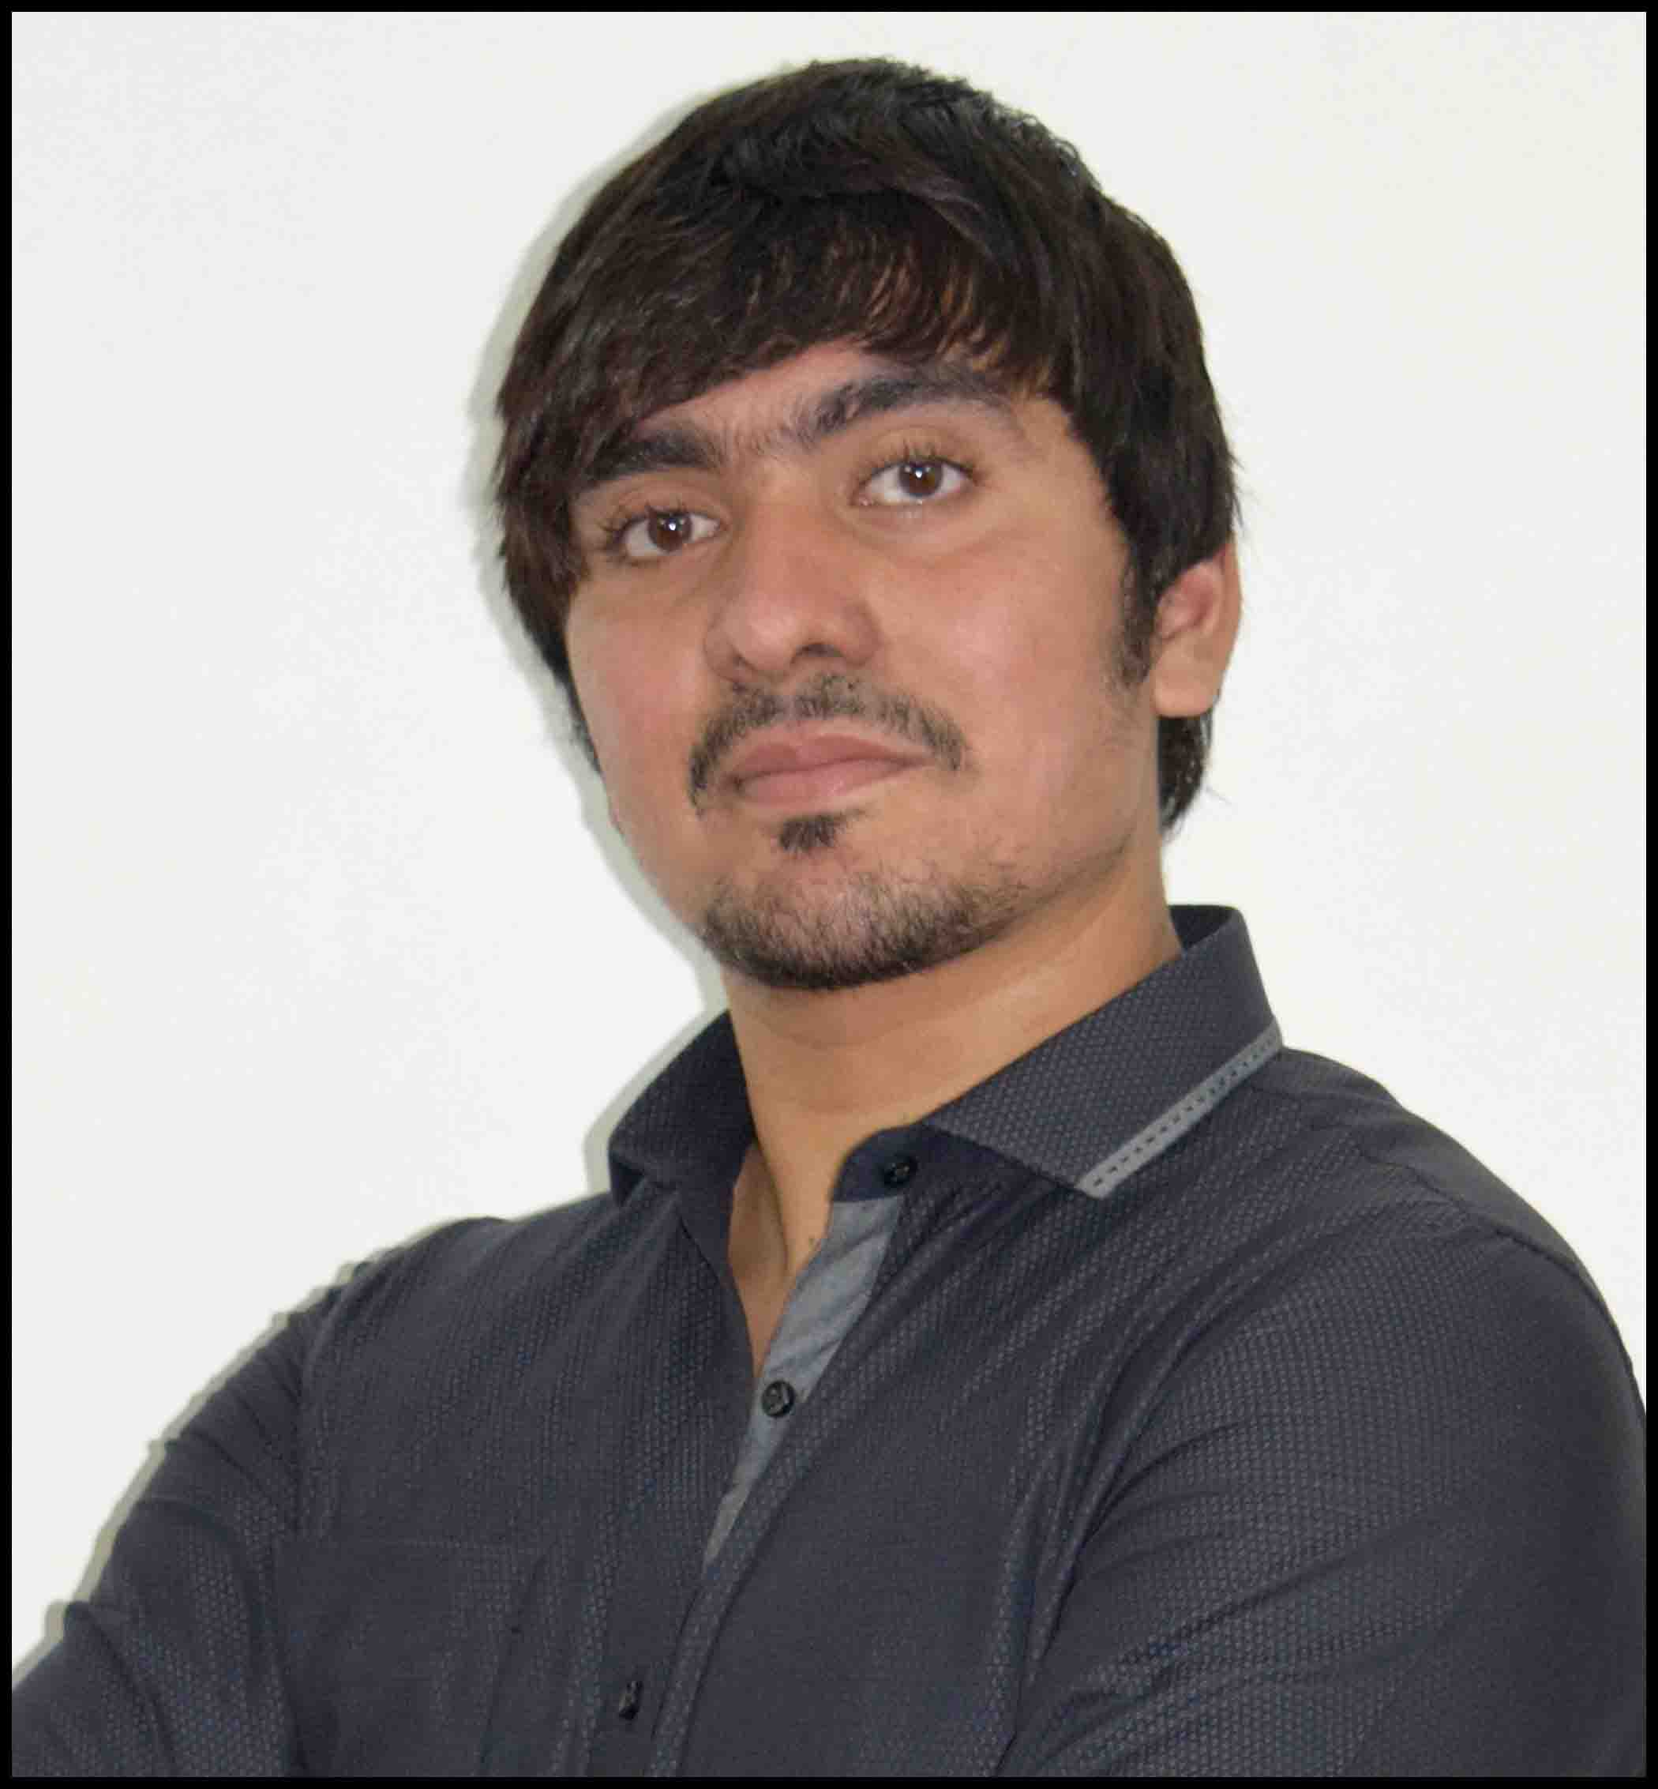

OBJECTIVE:

To be a professional who believes in making things happen along with fostering individual brilliance and creativity by taking up challenging task and to complete it effectively and efficiently.
Summary of Skills:
- Experience of providing satisfactory services to customersin various fields.
- Excellent knowledge of operating smart devices.
- Ability to administer in emergency situation and handling the situation easily.
- Friendly and helping attitude with passion for customer service.
- High respect for customers and committed to serve them better.
- Clean, professional, and pleasing appearance.
- Fluent in speaking English and making customers understand things easily.
- Very calm nature that fit in with any team and environment.
PROFESSIONAL EXPOSURE:
- Sindhu Logistics:Oct 2015 - Mar 2016
- Handling of customer queries regarding their shipments.
- Helping the new customers understand the procedure for import.
- Arranging of necessary documents required for clearance from the customer.
- Staying updated on consignments in transit.
- Making sure the customer is well informed and satisfied with the updates on their consignments.
- Maintaining records of all consignment coming under airfreight.
- Top Rated Seller on eBay: 2009 - Present
- Maintaining records on inventory.
- Analyze market status and introduce new products to stay in ahead in competition.
- Creating advertising material and listing the products in the Virtual shop.
- Releasing various attractive offers on special occasions to attract new customers and increase sales.
- Handling queries from buyers on products wholesale buyers.
- Resolving conflicts related to product fraud/ Fraud customers.
- Communicate with eBay representatives to resolve any shop related issues.
- Communicate with the courier company and assure fastest delivery.
- Sole Proprietorship Called as Novice:2008 - Present
- Sales and service of Computers, Laptop, Smart phones.
- Handling of professional cameras and also covered professional photography.
- Handling software related issues with smart phones and laptops.
- Been indulging in video editing for functions and short movies.
- Design advertising/print materials for small to mid-size companies, also included graphic designing, banners, certificates, logos and cards design etc.
- Video editing of documentaries, marriage shoots, local advertisement videos etc.
- Provide web-designing solutions, from building to hosting an entire site.

ACADEMIC QUALIFICATION:

Bachelors Of Commerce (B.com) from Karnataka University Dharwad, India

CERTIFICATIONS:

Logistics Course In Air Imports from Sindhu Logistics Bangalore, India
ACHIEVEMENTS:
- Awarded as the Best Student of the Year 2011-2012 in my 12th for my outstanding performance in Sports field, literature field and miscellaneous fields.
- Certificate of Appreciation for working on the official college promotion PPT 2012-2013.
- Certificate of excellence for designing all the certificates for the annual program of academic year 2012-2013.
- Won first place in 100 meter swimming in zonal level 2012.
- Declared and awarded as the best coordinator of the Wizard Fest organized by Anjuman Degree College and P.G Centre, though it was my first year in the college and I was selected for coordinating the fest for my performance on fresher’s day.
- Best fresher of the batch 2012-2013 in my degree college.
- 1st place in college quiz organized by the final year students 2012-2013.
- Secured 84.83% in my 12th.
- Winner of best manager event in following different fests AURA - SDM Mangalore, FLAMES - PA college Mangalore, Revels Manipal, Synergy Karwar, Telangana.
- Represented State level volleyball team from Degree College.
- Worked on a vision 2k15 official teaser video and inaugural video.
- Got selected in campus interview in karwar.
- Organized a zonal level fest called Wizards 2013, Anjumanii ascent 2014 and Vision 2015.
OTHER EXPOSURES:
- Been a photographer at Novice (Self Enterprise).
- Been a blogger since 2014 and have been earning from Google AdSense.
- Run a successful YouTube Channel since 2014.
- Been Indulge in Import-Export Business for last 2 Years.
PERSONAL DETAILS:
- Name: Mohammed Naif
- Date of Birth: 18th August 1993
- Gender: Male
- Nationality: Indian
- Marital Status: Single
- Visa: Tourist (Expires on December 10th 2016)
- Languages Known: English, Hindi, Urdu and Kannada

DECLARATION:

I hereby declare that the information provided in this document is true to the best of my knowledge.
Mohammed Naif

Mohammed Naif – 1851174
To interview this candidate, please send your company name, vacancy, and salary offered details along with this or other CV Reference Numbers that you may have short listed from http://www.gulfjobseeker.com/employer/cvdatabasepaid.php
addressing to HR Consultant on email: cvcontacts@gulfjobseekers.com
We will contact the candidate first to ensure their availability for your job
and send you the quotation for our HR Consulting Fees.

