CURRICULUM VITAE
Muzammil 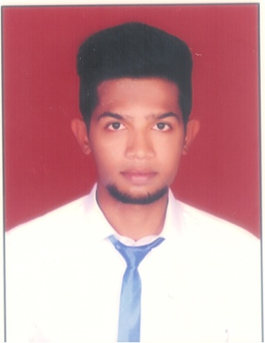
B.Tech –Mechanical Engineer
E-mail: muzammil.308674@2freemail.com

Career Objective:
My Objective is to Commit my skills, abilities knowledge and experience with an Organization that offers growth and also seeking a challenging position in a quality and growth oriented environment, where my knowledge can be shared and enrich.

Educational Qualification:

- Bachelor of technology (Mechanical engineering)from St.Peters Engineering College (Affiliated to JNTUH) (2015) with 66 %

- Board of Intermediate (MPC)from Narayana Junior College (2011) with 82%

3. SSC (Secondary School Certificate) from Navodaya High School (2009) with 81%

Technical Qualification:

- DIPLOMA IN –MEP(Electrical,HVAC,Plumbing,Fire Fighting) Designing &Drafting From Craft Educational Institute in the year 2014
- Knowledge in Clean Room Standards and Selection Of HEPA Filters
- DIPLOMA IN – Autocad Design & Drafting From Craft Educational Institute

Work Experience:

- Worked as HVAC Junior Engineer in HYDERABAD TUBES & DUCTS PVT LTD for 2 years (July 2014- August 2016)
- Knowledge about Site Managing Standards
- Knowledge About Preparing Quotations for the Enquiries About the product Hvac

Software Exposure

- Operating Systems : Windows Xp,7,8

- Office Automation : MS Office 2003, 2007.

- Software’s : AutoCAD 2012 ,2014, 2016

- “General Cooling Load Estimation Programme”
- “Ductu”
- “Mc-Quay Duct Sizer”
- “E-20-Block Load”

HVAC JOB RESPONSIBILITIES

- Heat load Calculations..
- Duct designing using formulae Ductulators, programs (Ducto & McQuay).
- Cooling tower selection - Evaporative losses calculations.
- Exhaust fan selection.
- Chiller, FCU,& AHU
- Calculation of Static Pressure
- Survey of Building.
- Kitchen ventilation, Hood system.
- Car parking ventilation & Toilet ventilation system.
- Preparing HVAC duct & equipment layouts, Sectional drawings, HVAC piping drawings, miscellaneous details, equipment schedule and notes and legend, Shop drawings for making equipment foundations and As built drawings.

ELECTRICAL JOB RESPONSIBILITIES:

- Design and Drafting Of Electrical Lighting,dB, & other Equipments.

FIRE FIGHTING JOB RESPONSIBILITIES:
- Fire water Demand & Fire water tank Calculation following NFPA Standards.
- Hose reel System
- Head Loss calculation for Fire water pumps system.
- Automated Sprinkler system and Water Hydrant system.
- FM-200 gas calculations as per the requirements
- Fire alarm system.

STRENGTH

- A team player with positive attitude and good sense of humor
- Deadline conscious with strong drive and initiative and ability to work well in time
- Ability to learn new technologies quickly.

PERSONALITY:

- Ability to work under pressure, willingness to improve, easy to adapt situation
- With standing long working hours, ready to accept any challenging assignment.

FIELD OF INTEREST:

- Learning new working standards
- Interested in Designing & site works

VISA DETAILS
Visa Status-Visit Visa

PERSONAL DETAILS:
Date of Birth : 22-08-1993
Sex :Male
Marital Status :Single
Languages Known :English, Hindi and Telugu
Nationality :Indian

