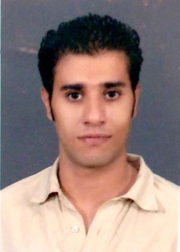 Mohamed
Mohamed.309516@2freemail.com

Dear Sir,
I believe your organization will enhance my knowledge in everything, so I'm seeking a job opportunity position that matches my ambitious and motivated personality, to gain on-hand practical experience, expert skills and professional training related to my qualifications in which will help in achieving major goals and to be participant afterwards within my field.

Career objective:
I have the honor to apply to your well-esteemed company, hoping to be granted the chance of serving your company, looking forward to have an interview at your convenience.

Personal profile:
- Date of Birth: 01-05-1985.
- Nationality: Egyptian
- Address: Dubai
- Marital Status: single
- Military Status: Exempted.
- UAE driving license
Education:
- B.S.C Bachelor of Information Technology ( IT )
- Management Information System (MIS) [Eng.Sec.]
- Modern Academy for Computer science & Management Technology in Maadi (MAM) "May 2009"
- Accumulative Grade: " GOOD "
- General Certificate of Secondary Education, (DON BOSCO)
- Diploma in mechanics and CNC from Don Bosco 2003

Graduation project:
- E-book
- Graduation project Grade: " very good "

Language Skills:
- Native language Arabic.
- English very good speaking & written.
- Italian fair speaking & written

Computer Skills:
- Excellent in windows XP & 7.
- Excellent in Microsoft applications.
- Excellent in using Internet.

Work Experience:
- Sales in El Masria for export and import [2008-2009]
- Sales in Bavaria Group in BMW Dep. [2009-2010]
- Customer care in Vodafone Egypt as call center agent [Comed value dep., High value & in Complaint management] [2010-2013]
- Etisalat UAE Tier2 Back Office. [Current]

Customer Service Skills:
- Relationship building
- Complaint Procedures
- Positive language
- Telephone techniques
- Effective questioning
- Managing objections
- Customer satisfaction
- Web chatting
- Sales Lead Generation

Personal Skills:
- Ability to interactive and fast enough to learn new tasks quickly.
- Ability to work well under pressure.
- Ability to work well with all levels of management and personnel.
- Ability to work in a group or individually according to the job requirements.
- Very good communication skills.
- Patient, self Motivated and enjoy challenges.

Interests & Hobbies:
- Traveling
- Technology
- Music listening

Goals:
To be an active part of a company that matches my activities and to be in a corporate team work to work with.

References:
Furnished upon request

Tips:
Long life learning (Ready to Learn)

