COVERING LETTER
ARSLAN

MECHANICAL DESIGNER

4-YEAR Working Experience in the Field of Mechanical.

Name ARSLAN
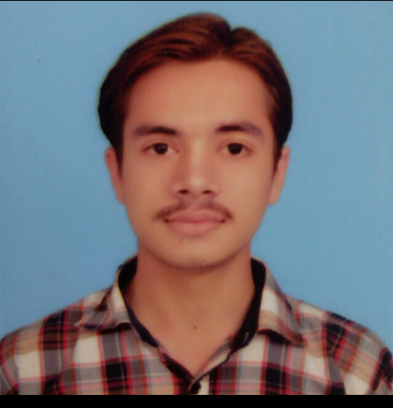
MECHANICAL DESIGNER

Date of Birth 03-03-1996 Religion Islam
Nationality Pakistani Marital Status Single
CNIC No. 35202-2948613-7
Languages ENGLIGH, CHINESE AND URDU.
E-mail arslan.309531@2freemail.com

  - WORK EXPERIENCE

1: AWF ENGINEERING (PVT) LTD.

  - EXPERIENCE

Designation: MECHANICAL SUPERVISOR (3-YEARS 04-13 TO 05-16)
Project: Industrial Shed.

2: JAMAL PIPE INDUSTRIES (PVT) Ltd.
Designation: MECHANICAL DESIGNER (JUNE 2016 TO CONTINUE)
Projects as Designer: 1-Cold Roll Pipe Mill 4-High Rollers. 2-Hot Dip Galvinizing Plant. 3- Steel Shed with overhead crane for Galvinizing Plant. 4- Jig Fixture for Hot Dip Galvinizing .
Responsibilities as CNC Programmer: Prepare the Program of CNC Plasma Cutting Machines by using the AutoCAD and Nesting Software to make G-Codes to Operate the CNC.
  - QUALIFICATION

- Matriculation: (Science) 2012. Board of Intermediate and Secondary Education, Lahore.
- F.Sc (Pre-Engineering): 2014 Govt. College Township Lahore.
- MECHANICAL DRAFTSMAN: 2016 Govt. Technical Training Institute Gulberg Lahore, Pakistan.
- CHINESE LANGUAGE: 2017 TEVTA, Lahore, Pakistan.

- Autodesk AutoCAD 2D & 3D.
SKILLS
EXPERIENCE

- Autodesk Inventor Pro 2016 3D Modeling, Assemblies, FEA Stress Analysis and Shop Drawings.
- Solidworks 2016
- Tekla Structure
- CNC programmer (plasma & oxy-Propane cutting).
- Ms.Office
- Chinese language

