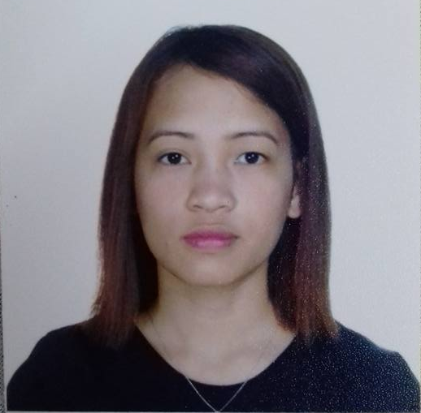  Gloria  Gloria.309556@2freemail.com  - Good level of competency in Microsoft Office applications: Word, Excel and Outlook  - Self motivated, reliable and confident.  - Positive attitude and ability to work well with others.  - Able to deal effectively, openly and positively  - Ability to work under pressure  - Trust worthy, hard working and efficient  - Fluency in both spoken and written English  - Bachelor of Science in Information Technology at Don Mariano Marcos Memorial State University - Philippines  2005-2010  - Achieved The Best Employee Award – October 2015 | For career and personal development. I am seeking a company where I can use my experience and education to help the company meet and surpass its goals.  - Office Assistant /Receptionist  National Printing Press  Dubai, UAE  2013 to 2017  Job Descriptions:  - Answering and managing incoming/outgoing calls.  - Receiving and interacting with visitors  - Compile, copy, sort, and file records of office activities, business transactions, and other activities especially in accounts and reception department.  - Making LPO, Delivery order and other reports.  - Office Staff (Estimator/ Encoder)  House Research and Development  Rosario, Cavite, Philippines  June 2012 to July 2013  Job Descriptions:  - Preparing all details of the House Designs for initial printing.  - Estimation and encoding data of the house plans.  - Checking of all the estimated details.  - In charge of final printing.  - Product Inspector/ Quality Control  Universal Leaf Philippines, Inc  Agoo, La Union, Philippines  July 2010 – June 2011  Job Descriptions:  - Identifying and Separating non-related materials of tobacco.  - Recording the number of non-related materials.  - Labeling tobacco type, name and kilos.
::
JOB PROFILE:
::
EDUCATION

ION
::
MAJOR ACHIEVEMENT
::
OBJECTIVE

::
WORK EXPERIENCES:

