Sai  E-mail: sai.309748@2freemail.com  DOB:11-Aug-1997(19)  Nationality: Indian |  |  |  |  | 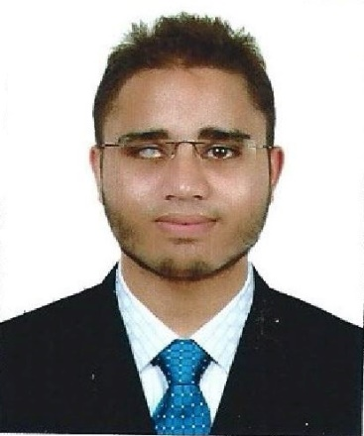
Summary | I am a talented and ambitious individual with a strong aptitude in accounts. I am keen to start my professional career. I am eager to have further training in the field of accounts while working with an experienced employer in a fast paced working environment.
Academic Qualifications | Shining Star International School  12th - Commerce stream - CBSE  Indian Islahi Islamic School  9thto 11th – Commerce Stream – CBSE |  |  |  |  | 2014 – 2015  75.2%  2011 – 2014  10thCGPA: 7.4
Professional Qualifications | Qualified:  Diploma in Applied Accounting – Through ACCA by completing first three papers of the course:  F1 – Accountant in Business  F2 – Management Accounting  F3 – Financial Accounting  Note: 6 Fundamental papers and 5 Professional papers remaining to become ACCA affiliate.  Current Education:  ACCA (Association of Chartered Certified Accountants) at Lynchpin Training Centre, AUH.
Additional Knowledge | Accounting | Professional |  | Personal
 | Bank Reconciliation  Budgeting  Maintaining Books of Prime Entry | Data Entry  Recordkeeping  Financial Data Analysis  Management Accounting  Financial Accounting |  | Teamwork  Listening Skills  Communication  Time Management  Meeting Deadline  Quick Learner
Work Experience | 2 Months service as Sales Executive at Timex IT Consulting, a well-known Software company.
Acquired Skills | - Well Organized  - Detail Oriented  - Excellent Communicator
Hobbies and Interests | - Attending Seminars  - Public Speaking  - Computer Games  - Sports Activities  - Tech Enthusiast  - Videography and Photography  - Travelling
References | Will be provided on request
Declaration | I hereby declare that the above-mentioned information is correct up to my knowledge and I bear the responsibility for the correctness of the above-mentioned particulars.

