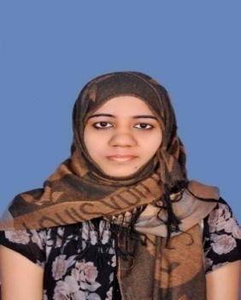
RESUME

Azmin

Email : azmin.309953@2freemail.com

Objective:

To grow along with an organization with sheer determination, an open mind, commitment and absolute passion with no compromise on human values.

Additional Skills:
Leadership Quality, Effective Communication Skills, Friendly, Hardworking, Sincere, Can work under pressure, Strong problem solving and analytical skills, Quick learning ability and having good understanding ability.

Educational Qualification:
Degree | Board/University | Percentage
SSLC | St.Thomas High School, Honavar | 71.84
XII thhigher secondary | Govt. of Karnataka. Dept. of pre university education | 62.16
Diploma in Education | Karnataka Secondary Education Board | 84.16
Bachelor of Business Administration | Karnataka University, Dharward | 62.33
Diploma Program in Computer Application | Indian Institute of Computer Technology, Bangalore | 85.01
Master of Business Administration | Sikkim Manipal University,  Managlore | -------

Extra Curricular Activities:

- Won school level prizes in various sports and athletics competitions,
- Achievement in cultural activities (drama,monoacting,etc…)
- And won many school level debate competition.

Work Experience:

- 1 year work experience in office clerk in honnavar -India.
- 2 year work experience teacher in private school in Honavar-India.

Computer Knowledge:

- Computer Fundamentals
- Dos and Windows(Ms word).
- Excel, Internet multimedia, Photoshop.
- Ms Power point, Page maker.
- Ms Access, Nudi.
- Tally(accounting package)

Passport Status:

- Date of Issue 27/08/2013
- Date of Expiry 26/08/2023
- Place of Issue Bangalore

Personal details:

Nationality Indian
Gender Female
Father’s name Ismail Sab
Language known Urdu - English, Hindi.
Marital status Single
Religion Muslim
Visa status visit

My Strength:

The blessings of my folks and the faith in god and my hardworking traits.

Declaration:

I hereby acknowledge that the information furnished above is true to my knowledge.

