Gautham (service advisor mechanical engineer-HYUNDAI)
B.E( Mechanical Engineer )
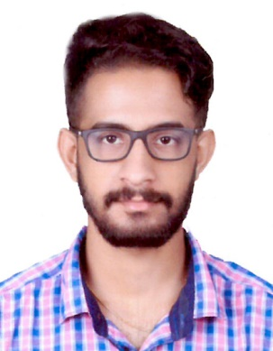
Gautham.310019@2freemail.com

MECHANICAL ENGINEER
2 year experience in HYUNDAI service projects &motors.
Project engineer(AUXFYS fuel installation, UAE-DUBAI)

Responsibilities-
Service project engineer(HUYNDAI 2014-2016)

*Inspecting the technical and machinery status.
*Field supervising.
*Supervising hydraulic Equipment installations
*Initializing and executing new projects.
Project engineer(AUXFYS fuel system installation 2016-)
*Inspecting site for fuel tank installation.
*Planning and analyzing AutoCAD room dimension of fuel tank installation.
*Planning and analyzing fuel tank AutoCAD dimension
*Evaluating and studying of PID,AutoCAD,LAYOUT & SECTION DRAWINGS.
*Preparing material submittal.
*Preparing technical submittal.
*Preparing consultant comments and rectifying the issues by site visit.
*Solving connection installation issues of day tank and bulk tank to generators.
*Supervising day tank/bulk tank fabrication.

CAREER OBJECTIVE
To work in a firm with a professional work driven environment where I can utilize and apply my knowledge, skills which would enable me as a fresh graduate to grow while fulfilling organizational goals.

BASIC ACADEMIC CREDENTIALS

Qualification | Board/University | Year | Percentage
B.Tech (Mechanical) | Anna University | 2014 | 68
HSC | CBSE | 2010 | 66
SSC | CBSE | 2008 | 62
Advance Diploma  (oil & gas production with fire &safety) | City & Guilds(United Kingdom certified) | 2014 | 90

EXPERIENTIAL LEARNING (SUMMER INTERNSHIP PROGRAM)

    - Project Title :- SUPER MANAGEMENT ON BRAKING SYSTEM.
    - Duration :- 8 MONTHS

IT PROFICIENCY

- Auto CAD
- Catia
- Solid works
- PPM(power plant management)
- Ansys
- Language: C++

CO-/EXTRA –CURRICULAR ACTIVITIE

- Executive Member of sport Committee in Vikas vidya niketan school.
- Executive Member of Event Organizing Committee in RVS college(Anna University).

ACHIEVEMENTS

- Won a bronze medal in relay in zonal in year 2007.
- Actively participated in various sports activities for inter school.

INTERPERSONAL SKILL

  - Ability to rapidly build relationship and set up trust.
  - Confident and Determined
  - Ability to cope up with different situations.

PERSONAL DETAILS

- Date of Birth :- 12/11/1991
- Language Known :- English, Hindi,Malayalam,Bengali,Assamese
- Marital Status :- Single
- Nationality/Religion :- Indian / Hindu
- Interest & Hobbies :- Music, books, travelling

