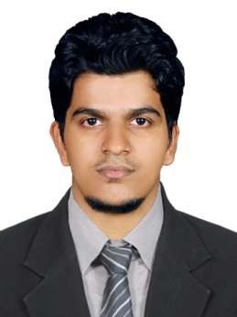
AFZAL CK
CV NO 310241

Objectives

To beoptimistic, sincere and self-starting , proven ability to initiate appropriate action, follow instruction
and carry out tasks in an efficient manner. Established repport diverse individuals and group
Education
 | 2010-2014 |  |  | B.E-Electrical and Electronics Engineering  Under ANNA University (2014)  JKK Munirajah college of Technology
2010  2008  IT Skills  OTHER SKILLS  CO-CARRICULAR  ACTIVITIES  EXPERIENCE  Proficiency Languages |  |  |  | Higher Secondary  Science (2010)  Vocational Higher Secondary School ,Vadakara  SSLC  KRHSS PURAMERY (2008)  PURAMERY ,KOZHIKODE Dist.  - Office Package: Microsoft Word, Excel, PowerPoint etc.  - Mat LAB  - Graphic Design  - C,C++  - Leadership skills  - Working in teams.  - Presentation skills  - Participated in MEGA TECHNICAL EXPO,SCIENCE AND TECHNOLOGY EXHIBITION 2011 & 2015 at JKKM INSTITUTION.  - Participated in various“ TECHNICAL PROGRAM”.  - Participated in various QUIZING PROGRAM  - OPERATOR (On contract)  Company: K.S.E.B 220KV Substation orkkatteri, Kerala.(March 2015 to may 2016)  I have been involving in the operation and maintenance of  - 220kv/110kv 100 MVA Transformer&110kv/11kv 12.5 MVA Transformer  - SF6 Circuit Breaker , Vacuum Circuit Breaker and Air Breaker  - Current Transformer, Potential Transformer and Current Voltage Transformer  - Control Room Operation

Language | Read | Write | Speak
English | Yes | Yes | Yes
Malayalam | Yes | Yes | Yes
Hindi | Yes | Yes | NO
Arabic | Yes | Yes | No

Personal Profile
To contact me please talk with my HR Consultants at www.gulfjobseeker.com who have already screened my profile in detail. UAE Phone: +9714-3970978 India Phone +917926400411
http://www.gulfjobseeker.com/employer/employerservices.php

: AFZAL CK
: KUNAHAMMED CK
: 03/06/1992
: Male
: Single
: MUSLIM
: O+ve
: Indian
Name
Father's Name
Date of Birth
Gender
Marital Status
Religion
Blood Group
Nationality

