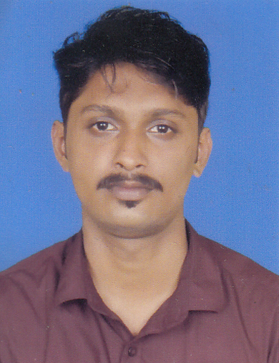Shamnas.P
To contact me please talk with my HR Consultancy www.gulfjobseeker.com
Phone-UAE: +9714-3970978 India +917926400411
http://www.gulfjobseeker.com/employer/employerservices.php

Summary
Capable Accounting Assistant successful in completing tasks in an extremely deadline-driven environment. Extensive knowledge of accounting software and processes, proficient in prioritizing and finishing tasks in a timely manner, yet flexible to multitask when needed. Works well independently as well as collaboratively in a team setting.

Experience
Infomac Systems (Kerala, India)
Account Assistant (August 2015-Sept 2016):
I am currently in charge of providing financial information to the management by analyzing various accounting information.
- Used automated accounting systems for data input and obtaining report.
- Provided quotations for new and renewals business.
- Maintained accounting ledgers.
- Processed various accounting transactions.
- Maintained records of payment information.

Secure Solutions (Kerala, India)

Trainee Accountant (May 2014- June 2015)
- Data entry and retrieval.
- Liaised with businesses.
- Attended the needs of multiple clients simultaneously.
- Collated and formatted data to be presented to the team leader.

Skills and Other Achievements
- Proficient in the various aspects of Microsoft office in relation with bookkeeping and familiar with the accounting software Trade easy.

- Excellent analytical & problem solving skills.

- Exceptional interpersonal and communication skills, including good presentation and report writing skills, a fluent speaker of English, Hindi and Malayalam.
- Well versed with the basic accounting principles, international accounting standards and process which include recording transaction in the books of accounts and reconciliation of the same.

Education

Bachelor of Business Management (Sreenivasa Institute of management, Mangalore 2012-2015);

C.B.S.E higher secondary school examination (S.N.Vidya Mandir, 2010-2012).

Personal Profile

Date of birth : 17 March 1994
Nationality : Indian
Visa details : Visit Visa (Valid Till 03 Jan 2017)
Marital status : Single
Interests & Hobbies : Photography, Travel

