Ajith
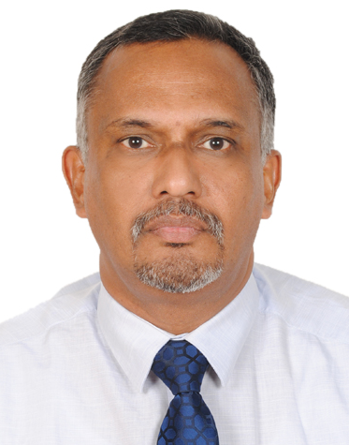
E-Mail: ajith.311015@2freemail.com
Senior Professional |Sales & Marketing Management| Exports | Channel Management |Project Sales.
Industry: Construction/ Building Materials.
Location Preference: Middle East / India.
Driving Licenses: QATAR, OMAN, INDIA and U.A.E.
PROFILE SUMMARY
A dynamic professional with over 27 years of experience in Sales (Trade & Project) & Marketing Management. Exports Operations Management. Channel Management. Business Development. Key Account Management. New Market Development. P&L Operations.
Expertise in blending creative intellect / insight and sharp planning skills for managing business operations& meeting top / bottom-line objectives with very good leadership skills.
Expert in the sales and marketing of building materials like pipes and fittings, steel cable management systems, sandwich panels, steel roofing sheets, water proofing membranes, construction chemicals, electric cables, plywood, tiles, pavers, operable partitions, sports floorings etc.
ORGANISATIONAL EXPERIENCE
Feb 2016 onwards working as Assistant General Manager – Sales & Exports, with M/s Amiantit Oman Co LLC, UAE
Key Result Areas
. Entrusted with P/L responsibility for GCC except Oman for PVC, PPR & HDPE pipes and fittings.
June 2012 to Feb 2016 with, Techno Plastic Industry, LLC, Muscat, Oman as Sales and Export Manager (PPR pipes & fittings)
Key Result Areas
- Entrusted with the responsibility of managing P/L activities with a set target of $ 10 million per year
- Covering projects and appointing dealers in Oman, UK, Algeria, Lebanon, Libya, Ethiopia, Sudan, Egypt, Yemen, Iraq & Saudi Arabia, Qatar, Bahrain, Kuwait, UAE, India & Sri Lanka, developing market in Europe, Africa and Asia
- Carrying out technical seminars and presentations for Architects, Consultants and Builders to establish the brand and business
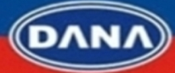
- Initiated internal brand-identity communication with a resultant increase in sales in Techno Plastic LLC
Mar’11-May’12 with M/s Dana Steel Processing Industry LLC, Dubai as Sales & Marketing Manager (Steel cable management systems, steel roofing sheets, sandwich panels etc).
Key Result Areas
- Involved in creating new accounts viz.: M/s Mercury EMC LLC, Abu Dhabi, M/s Al Malwaya EMC, UAE, M/s Al Dasthoor LLC Oman, M/s. Descon Eng. Cont. LLC Abu Dhabi, M/s IEMANTS Steel Cont LLC, Qatar , M/s 3W Networks, Dubai , M/s ABB Ltd Abu Dhabi, M/s Cirta EMC LLC Abu Dhabi, M/s Voltas LLC, M/s Hawk international Yemen , M/s Kharafi National Abu Dhabi, M/s Gasco Abu Dhabi, M/s Borouge Abu Dhabi ,M/s Tecnimount SPL ,Italy, M/s Hyundai LLC, Abu Dhabi & CCC SRL
Jan’10-Mar’11 with M/s STP Limited, South India as Assistant General Manager-Sales (Waterproofing & construction chemicals)
Key Result Areas
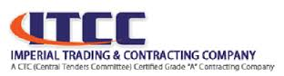
- Supervised P / L activities and involved in project & trade sales management of South India.
Jun’09-Jan’10 with M/s. Imperial Trading and Contracting Company LLC, Qatar as Assistant Manager - Sales (Oman Cables).
Key Result Areas
- Managed sales and achieved collection target of QAR 12.00 million / month. Liaised with clients like M/s. Mercury Middle East LLC, M/s. Gulfar Al Misnad LLC, M/s. Ebid Group, M/s. M.H. Al Muftha , M/s. Prominent Group, M/s. Dodsel Ltd., M/s. Infotech Group, M/s. Al Badar Group, M/s. Voltas Limited, M/s. Hampton International LLC., M/s. Dar Al Handash , M/s. MZ Partners, M/s. Sketch Consultants etc.
Nov07-May’09 with M/s. Scorpio Tiles Limited, as Assistant General Manager - Sales for South India(Tiles & Pavers)
Key Result Areas
- Functioned as responsible personnel for INR 30.00 crores temporary sales target area with 3 Depots, 140 Associate Dealers, Builders, Consultants and Architectural Projects.
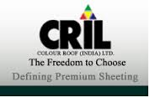
Apr’03-Oct’07 with M/s: Color Roof India LTD as Sales & Marketing Manager for South India (Color coated steel roofing sheets).
Key Result Areas
- Worked as Profit Centre Head, managed sales through Architects, Consultants, Projects, C&F Agents & Dealers
- Successfully fulfilled the responsibility of supplying color coated steel profiled roofing sheets to large projects like M/s. Lulu International Convention Centre, Trissur. M/s. Southern Naval Academy, Ezhimala, M/s. Info Park Limited, Cochin, M/s. Kitco Limited, M/s. Rubco Limited, M/s. Cochin Special Export Processing Zone, M/s. Indo Burma Petroleum Corporation Limited, M/s. Hindustan Petroleum Corporation Limited/s. Indian Oil Corporation Limited, M/s. Techno Park Limited etc.
PREVIOUS EXPERIENCE
Aug’01-Mar’03 with M/s: The Indian Plywood Manufacturing Company Limited, as Area Manager for Kerala state 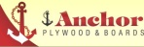
Apr’98-Aug’01 with M/s: Garware Polyester Limited, as Sales Executive and Area Sales Manager for Kerala state.
Apr’95-Mar’98 with M/s: Makar Mercantile Limited, as the Area Sales Executive for Kerala state. 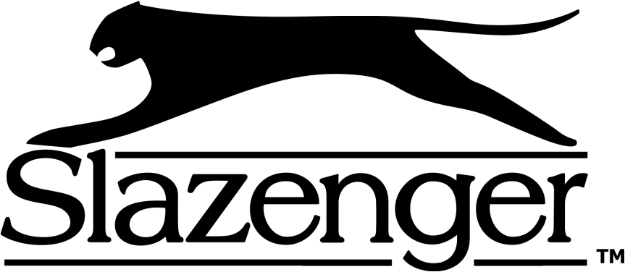
Oct’92-Mar’95 with M/s: Dynavision Limited, as Sales Executive in Kerala.
Dec’90-Sep’92 with M/s: Consolidated Coffee Limited, Sifco Division, as Sales Representative for Kerala state. 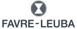
Apr’89-Sep’90 with M/s: Eureka Forbes Limited (A TATA Company), as Sales Representative in Kerala.
ACADEMIC DETAILS
1989 Post Graduate Diploma in Marketing Management
1985 B.A. from SKV College, Trichur, Calicut University
PERSONAL DETAILS
Date of Birth: 22nd April 1965
Nationality: India.
Passport status Valid till April 2023.

