Curriculum Vitea

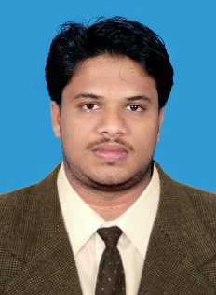
SAJEEB
SAJEEB.311167@2freemail.com

Career Objectives

Indeed to build a career with leading corporate of good environment with committed and dedicated people which will help me to explore myself fully and release my potential.

Educational Qualification

- S.S.L.C from Board of Public Examination, Kerala
- Plus Two from Board of Higher Secondary Examination, Kerala
- B.Com from Calicut University
- M.Com from Calicut University

Professional Qualification

- Diploma in Financial and Foreign Accounting (TALLY,PEACHTREE)
- MS Office
- Photoshop

Professional Experience

Mens & Herzone Readymade and Textiles ,Ponnani ,Kerala ,India (From 01-02- 2013 to till date.

Responsibilities;
- Data Entry and Records management.
- Accounting with Tally ERP 9 and Acro business information system.
- Involvement in day-to-day accounting operations.
- Maintained schedules of accounts receivables and payables.
- Calculate and distribute wages and salaries.
- Maintained Daybook, Sales, Purchase, sales returns and posted ledgers.
- Prepare all vouchers and manage bank statements.

Professional Skills

- Qualities Good Leadership
- Capable of Managing Tasks and Hard Working
- Ability to take initiative.
- Self motivated.
- Efficient problem solving

Languages Known

- English
- Hindi
- Malayalam

Personal details

Date of Birth : 12/01/1993

Religion : Islam
Sex : Male
Marital Status : Single
Nationality : Indian

Declaration

I hereby declare that the above mentioned details are true and correct to the best of my knowledge and belief.

