Muhammad
Muhammad.311247@2freemail.com

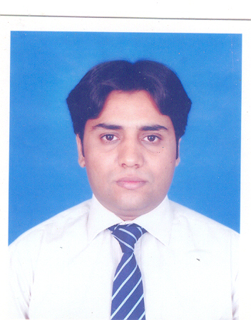
Objective

To be part of the professional organization and work in challenging environment which offer opportunity to grow development and contribute to the growth of the organization.

Personal

Date of birth : 3rd Mar 1982
Religion : Islam
Nationality : Pakistani
Marital Status : Married

ACADEMIC QUALIFICATION

- Matric (Science)
- FSC (Pre-Medical)
- BSC (Botany, Zoology & Chemistry))
Skills
- Software Microsoft Excel, Microsoft word, Microsoft power point, In page.
- Operating System Window XP Professional, Window 2000 Professional.
Job Experience
- 1 year experience in High noon Laboratories as a Sales Promotion Officer.
- 3½ years experience in Platinum Pharmaceutical (Pvt.) Ltd as a Sr. Sales Promotion Officer.(Dentistry Div)
- 3 years experience in Kaizen Pharmaceutical (Pvt.) Ltd as a Sr.Sales Promotion Officer.(Dentistry Div continue)
COMPUTER ACTIVITIES

- Computer Hardware and Software specialist.
- Windows troubleshooting.
- Basic computer Programming.

