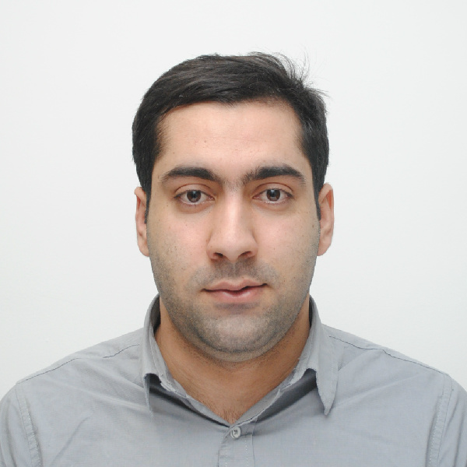
_{CURRICULUM VITAE}
Abdul
Abdul.311252@2freemail.com

PERSONAL PROFILE

Friendly personality, great communication skills, troubleshooting issues, and coming up with solutions in a timely manner, energetic, ambitious and responsible, Negotiation, Marketing Management, international sales, Market Research, leadership person with experience of more 4 years as administrative assistant studied Master of Art (International Business) at University of Greenwich (London, UK).I worked at SAKHIZADA, Co. Ltd as sales manager and my responsibility was selling the products, promote the business by attracting new international costumers therefore; I am the experienced of working with costumers with different cultural. I am excellent in working with others to achieve a certain objective on time and with excellence.

CAREER OBJECTIVES
Dedicated and motivated Master of Art in international business student seeking for a challenging middle level managerial position in corporate sales and marketing where I can effectively and efficiently utilize my time, knowledge, skills and capabilities to enhance and add value to the company and my career prospects.

EDUCATIONAL HISTORY

2015- 2016: University of Greenwich (London, UK) - Master of Art (International Business) “Merit”
- Academic Session 1

- International Marketing, Global Networks & Innovation, E- Logistics & international

- Supply chain

- Management, Foundations of Scholarship and Research.

Academic Session 2

- Financial and Management Accounting, Global Strategy: Analysis and Practice,

- Pathway Specialization Project, Global Business and Sustainability, Managing and

- Leading People AcrossCultural Borders.

2011-2014:University of Pune- BBA (Marketing Management) “First Class”

Sales &Retail Management (76%), Personality Development (75%), Business Law
(70%) Taxation (60%), Supply& Chain Management (60%), Accounting (64%),

Information System (68%),

EMPLOYMENT HISTORY

2008- 2011:SAKHIZADA HERAVI CO., LTD.Banaye 5 District 3, Heart, Afghanistan
This is an export and Import Company, mainly operating on exports of Wool cashmere and Dry fruits. The customers of the company are mostly in countries such as, USA, Belgium, UAE and India.

VOLUNTEERING

June – December 2012, FOTSA Coordinator in Ness Wadia College of Commerce, Pune, India.

CERTIFICATES

2012- IT certificate (HTML, C++, MS Office)

KEY SKILLS

General Business Operations, Organization, Office Support, Goal setting, Negotiation, Relationship Building, Marketing Management, international sales, Market Research, leadership, Presentation, Team work.

Technical Skills:Computer Literacy (Including internet, email and word processing) Proficient in using main Microsoft Office applications, HTML, C++, FCC, Networkin

