CURRICULUM VITAE
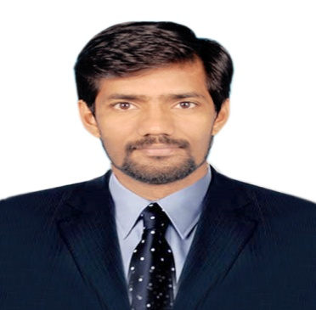

SATHISHKUMAR
HAAD PASSED
Registered Nurse with DHA Eligibility Letter
Data flow Barcode
ACLS & BLS Certified with AHA
Mobile No : C/o 0501685421
E-mail ID : sathishkumar.311266@2freemail.com

CAREER OBJECTIVES
To work in an environment that motivates excellence, passion for work and loyalty towards the organization that will strengthen my personal character.

TOTAL YEARS OF EXPERIENCE : 5 Years 6 month
- CHETTINAD HOSPITAL, CHENNAI,11th Sep 2014 – 14th Nov 2016
Emergency trauma care Registered Nurse (1200 Bedded)

- SODEXO INTERNATIONALS, DUBAI, 8th Feb 2014 – 12th Jul 2014.
Kandahar Project, USA base. Registered Nurse

- R.K NURSING HOME HOSPITAL, CHIDAMBARAM, Male Nurse ( 100 Bedded )
Emergency Room -5th Sep 2008 to 22nd Jul 2010 & 15th Nov 2012 – 3rd Feb 2014.

PROFFESIONAL QUALIFICATION
EDUCATION | INSTITUTION | UNIVERSITY | YEAR OF PASSING | PERCENTAGE
PcBsc Nursing | Sri Vijay Vidyalaya College Of Nursing | The Tamilnadu Dr.M.G.R.Medical University | September/2012 | 65%
Diploma in Nursing | Sharmila College Of Nursing | Directorate Of Medical Education | June/2008 | 68%

PROFFESIONAL REGISTRATION
REGISTRATION | COUNCIL | YEAR | REGISTRATION NUMBER | VALIDITY
RN-RP | Tamilnadu Nursing Council | 2009 | 91707 | 06-Aug-2018
REGISTERED NURSE | Dubai Health Authority | 2016 | DHA/LS/28102015/521352 | 08-Feb-2017
REGISTERED NURSE | Health Authority of Abu Dhabi | 2016 | AGN158897 | 25-May-2018
ACLS | American Heart Association | 2015 | 877dce638a3b | Oct-2017
BLS | American Heart Association | 2015 | 6c39cf69cdaa | Oct-2017

PASSPORT DETAILS
PARTICULARS | ISSUED PLACE | DATE OF ISSUE | DATE OF EXPIRY
PASSPORT | CHENNAI | 13-Apr-2010 | 12- Apr -2020

PROFICIENCIES
- Responsible for maintaining registers and standards in the emergency room.
- Efficiently and knowledgeably provided nursing care to all ER patients, handle intubations, AMBU bag, mechanical ventilation, Defibrillations, AED etc.
- Administered critical IV medications such as Atropin, Adrenaline, Amiodrane, Adenosine Dopamine, Insulin, Nitro-glycerine and etc.
- Assisted in the care of multiple traumas, cardiac arrest, pulmonary edema, hypoglycemia, hypertensions, bronchial asthma, CVA stroke codes, and conscious sedations.
- Administered IV fluids and medications including antibiotics, packed RBC’s and narcotics, while carefully monitoring for side effects or any adverse reactions.
- Taking blood work, Foleys catheter insertion, inserting peripheral IV’s, Ryle’s tube, minor suturing, gastric lavage etc.
- Analyzed client ABG’s / metabolic profiles, radiological results and EKG readings.

CHARACTER REFERENCE
Mrs.Amutha.RN(Chief Nursing Superintendent) | Dr.Ashwinprasad, MD, (EM) MRCEM (UK), FICM,
Email:amuthaj@chettinadhealthcity.com | Email :drashwin@chettinadhealthcity.com

PERSONAL PROFILE
Name : Sathishkumar
Age & Sex : 30 Year, Male.
Marital Status : Single
Nationality : Indian
Religion : Hindu
Date of Birth : 05/06/1986
Languages Known : English, Tamil, and Working Knowledge in Hindi.
Visa Status : Tourist
Availability for the position : Immediately

DECLARATION

I hereby declare that the information given above is accurate and to the best of my knowledge.

Place: DUBAI Your’s sincerely,

Date: Nov-2016 (SATHISHKUMAR)

