CURRICULUM VITAE
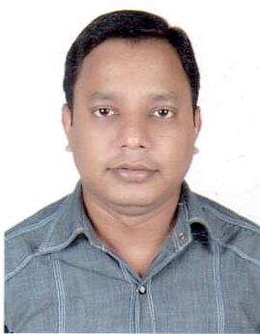

ASHRAF
Mob: C/o 971503718643
Dubai, U.A.E.
E-Mail : ashraf.311385@2freemail.com

Objective:-

To work in an environment which offers a good opportunity to share my knowledge and skills with others and participate my self and work towards for a complete satisfaction of the company.

Educational Qualification:-

- Passed Madhyamic (10) Examination under West Bengal Higher Secondary Board.

Work Experience:-

- Working as a Captain (in India Palace Restaurant (SFC Group) in Dubai, U.A.E. from Feb 2012 to till date.

- Worked as a Restaurant Captain in Jimmy Kitchen Kolkata, India from March 2011 to Sep 2011.

- Worked as a Head Waiter in Spice Lounge Restaurant Dubai, U.A.E. from Nov 2008 to Aug 2010.

- Worked as a Waiter in Hotel Anmol Residency India from 10/04/2003 to 20/11/2006.

Job Summary:-

- Supervising daily operations of the restaurant.
- Maintaining service standards at all times and highest level of customer satisfaction.
- Handling guest complaints and queries.
- To ensure adequate staffing at all times of the operation of the restaurant.
- Maintaining staff duty schedule and inventory of all equipments.

Languages Known:-

- English, Hindi, Bengali (Read, Write & Speak)

Achievement/ Award:-

- Awarded Best Employee of the Month in April 2015 from India Palace Restaurant.

Strengths/ Skills:-

- Fluent in English.
- Good communication skills.
- Basic knowledge of Computer
- Sincere & honest.
- Hardworking, Team Leader & Ability to work under pressure.

Personal Details:-

Nationality : Indian
Date of Birth : 27/06/1977
Gender : Male
Religion : Islam
Marital Status : Single
Visa Status : Employment

Declaration:-

I hereby declare that the above mentioned statement is correct & true to the best of my knowledge & belief.

Place:
Date: ASHRAF

