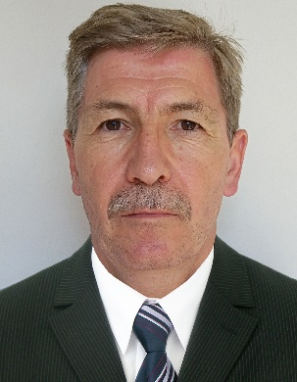
CURRICULUM VITAE

Name: Attila– male

Date of Birth: 22.01.1959.

Marital status: married with one child

Qualifications:

1981-1984 - University of food, technical industry and
economy
Galati – Romania (Europe)

Faculty of Production Engineering

1986 – Cours for Experts of Tasting – Bucharest
Romania (Europe)

1991 – Psichological course – Sopron Hungary (Europe)

1997 – HACCP – British Royal Quality Assurance
Institution – Siófok – Hungary (Europe)

Professional experiences:

2015 – present Frigoglass Dubai – Jebel Ali – UAE
Glass Industry

Factory Manager – Legal Representative

Responsibilities: - production
- maintenance
- quality
- investment
- controlling
- costing,
- EHS
- decoration department
- plant business result
- security

2008 - 2015 – Owens –Illinois USA - Hungary – Glass
Container - packaging

Managing Director - Factory Manager

Responsibilities: - production
- sales
- maintenance and investment
- quality control and assurance
- HR
- supply chain
- finance
- cost – cash management

- controlling
- EHS
- full P&L responsibility
Results: 3000 KEUR saving/4 years
Number of people: 176

2004-2008 – FRAMA GPV France Ltd –Paper and printing industry
Budapest - Hungary

Factory Manager – Executive Director

Responsibilities: - production
- maintenance and investment
- quality
- finance
- cost - cash
- HR
- sales
- supply chain
- full P&L responsibility
Results: 400 KEUR saving/ 3 years
Number of people: 100

2001-2004
Perfetti-Van Melle Ltd – food-confectionery
Gyál- Budapest - Hungary

Factory Manager

Responsibilities: - production – 3 factories
- maintenance and investment
- quality control and insurance
- supply chain,
- HR
Results: 1000 KEUR saving / 3 years
Number of people: 400

1998 – 2001 – Bongrain Group (Pannontej) –food-dairy
Zalaegerszeg –Hungary

Factory Manager

Responsibilities: - production
- maintenance and investment
- quality
- supply chain
- controlling, costing. cash
- HR
- general administration
- full P&L responsibilty

Results: 5.000 KEUR EBIDT in three years
Number of people: 240

1994 – 1997 – Dr Oetker Hungary –food – bakery industry

Production Manager

Responsibilities: - production (back powder and
frozen pizza
- maintenance
- quality
- supply chain
Results: 500 KEUR saving/ 3 years
Number of people: 250

1988 -1994 – Heineken (Brau AG) Brewery-Sopron –Hungary

Technologist-production manager

Responsibilities: - fermentation and filtration

Results:- big volume of investment (1000KEUR)
- several scientific articles in the
technical journal „Brew Industry”
- achievements in production
rationalizing

Languages: - Hungarian – fluent – mother language
English – fluent
German – intermediate- (good communication
and negotiation level)
Romanian – fluent
French - basic

Strengtheens: - strong customer and company result (profit)
oriented
- full P and L responsibility
- full knowledge of new and modern
management methodologies ( LSS, TPM,
consigment stock system.
- strict financial (cost) controll (crisis
management) and cash management
- strong motivation and leadership skills
(psichological experience)
- strategic and process thinking
- productivity increasing
- high level of negotiation skills

Others: being free from harmful habits
Driving licence: „B” category (light vehicle)

Hobbies: psichology, traveling, sport

E-mail address: attila.311423@2freemail.com

