311458@gulfjobseekers.com
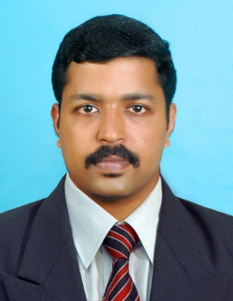

MEDICAL SALES REPRESENTATIVE

PROFILE-
- Sales professional with a proven track record in medical sales.
- Passionate to grow, develop and excel in the field, using excellent sales and assertiveness skills.
OBJECTIVES:
Work in a competitive sales environment in which focused application of sales skills will achieve success and even exceed the organization’s sales goals and objectives.
PROFESSIONAL EXPERIENCE
- MACLEODS PHARMACEUTICALS,MUMBAI 26-JUNE 2009- 11 DECEMBER 2015
Medical Marketing Executive

HIGHLIGHTS OF SALES PERFORMANCE
Sales Initiatives:
Performed as a link between pharmaceutical company and doctors, pharmacists and hospital teams – Was constantly present at medical presentations to ensure thorough knowledge/awareness regarding latest/new medical products on the healthcare market.
- Specialized in hands-on knowledge/experience in scores of medicine/medical devices and addressed medical professionals’ questions convincingly.
- Worked independently and as a team to generate professional meetings with health-care professionals in order to sell medicinal products.
- Set up conferences and seminars for doctors, medical staff and professionals so that this information could be relayed optimally
- Promoted and presented company’s pharmaceutical/medical-device products at hospitals, clinics and pharmacies.

- SHEILD HEALTH CARE , KERALA JUNE 2008- JUNE 2009
Medical Marketing Executive

HIGHLIGHTS OF CONTRIBUTIONS
Sales Initiatives:
- Managed hospital and medical center accounts.
- Worked with team managers to create effective business plans for increasing sales in particular areas.
- Arranged appointments with doctors, pharmacists and medical teams to raise awareness of latest medicines launched.
- Planned work schedules on weekly and monthly basis with the help of sales team involved in different areas; discussed future targets with each area’s sales manager.
PROFESSIONAL DEVELOPMENT
- Attended company’s meetings, and was updated on products briefings to obtain in-depth knowledge on the subject of different medical products and medicines.
- Kept abreast of new developments, predicted positive and negative impacts on the health industry and adapted strategy accordingly.
OTHER CONTRIBUTIONS
- Maintained good relationships with medical and administration staff.
- Prepared sales reports and marketing strategies.
- Worked closely with Regional Manager and Area Manager to report on customer feedback.
- Followed up on all prospects and possible quality leads as directed by the seniors.
EDUCATIONAL QUALIFICATIONS
- BSc Chemistry Mahatma Gandhi University 2003-2006
Kottayam, Kerala
- Higher Secondary Board NSS Higher Secondary School 2001-2003
Karukachal, Kottayam
- Secondary School Leaving St. John’s Baptist Higher 2001
Certificate Secondary School, Kottayam

COMPUTER LITERACY
- Familiar with Windows 98/XP, Excel, Microsoft Word 2007.
- Internet surfing and e-mail operations.
RIVING LICENSE
UAE Driving license
Indian driving license

