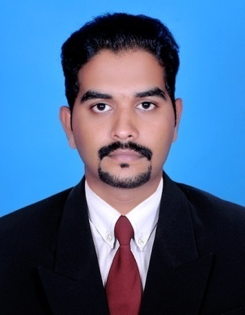
Resume
Binesh
Binesh.311578@2freemail.com

PERSONAL SUMMARY
To be a part of progressive organisation and to work with a team for achieving the organisational goal there by developing my skills and gaining satisfaction in all aspects.Now I am looking forward to a making a significant contribution to a Business organisation that offers a genuine opportunity for progression.
PROFILE SUMMARY
- Having 3 years of experience in Accounts and Administration.

- Having Experience in Sales and Customer relationship.

- Hold a master degree in Commerce (M-com)

- A quick learner and take initiative to meet and resolve challenges.

CAREER HISTORY
ABC MOTORS (ROYAL ENFIELD)
ASSISTANT ACCOUNTANT (From Sept 2013 to Sep-2016)
Job profile
- Handling of accounts on day to day
- Preparing invoices.
- Handling of bank reconciliation.
- Checking the monthly sales income report and correcting the variance
- Preparation of daily collection reports
- Handling petty cash, accounts receivables and payables
- Preparing monthly journal reports
- Liaising with suppliers and buyers
Additional duties
- Dealing with various financial auto loans companies.
- Stock checking.
- Motor Insurance policy preparation and Data entry.
- Special responsibilities by the audit department.
ACADEMIC QUALIFICATIONS
- M.com (2013-2016)
- B.com (Computer application)-2009-2012
- PLUS TWO ( Commerce) 2007 – 2009
- SSLC 2007
PROFESSIONAL QUALIFICATION
- Tally ERP
- Excellon (DMS)& Invoice.
- Peachtree, Daceasy
- Ms word, Ms excel
PERSONAL STRENGTHS
- Maintaining positive attitude in the face of changes in work assignments.
- Sense of responsibility
- Ability to keep calm under work pressure
- Ability to motivate subordinates
- Self starter and disciplined.
HOBBIES
Yoga,Reading, Playing puzzles and Internet browsing
PERSONAL INFORMATION
Date of Birth : 17th May 1992
Nationality : Indian
Languages : English, Hindi, Malayalam
Visa Status : Visit Visa
Marital status : Single
REFERENCES
Available on request
Place & Date

