CURRICULUM VITAE  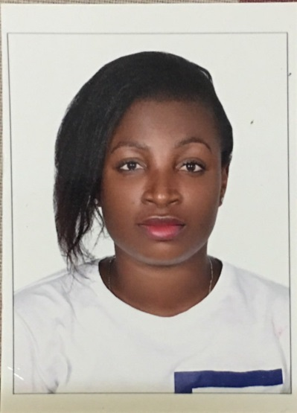  Professional skills  - Analytical skills  - Proficient writing skills  - Communication skills  - Customer service  - Advertising skills  - Public relation skills  - Sales and Marketing skills  - Secretarial skills  Date Of Birth:31st july, 1990  Gender : Female  Marital Status : Single  Nationality:Nigerian  Hobby :Reading, travelling, meeting people, football | OBJECTIVE  To obtain a position in a progressive and esteemed educational setting that will fully utilize my teaching skills while giving space for self-development, active participation among learners irrespective of their attainment levels  PERSONAL ATTRIBUTES  - Positive attitude  - Enthusiastic  - Dependable  - Resilient  - Team player  - Proactive thinker  - Taking initiative  TEACHING EXPERIENCE  Five years teaching and tutoring experience in Nigeria:Biology, Basic science and Mathematics.  2007- 2008: Nursery and Primary School Teacher  (OurSavior Nursery and Primary School, Ondo, Ondo State Nigeria.)  2010- 2013: Secondary School Teacher  (Happy Day Group of Schools Ado Ekiti, Ekiti State Nigeria.)  2014-2015: Nursery and Primary School Teacher  (Happy Modern Nursery/Primary School, Ondo, Ondo State Nigeria.)  November, 2015 to date: Waitress  (National Corporation for Tourism and Hotels (ADNOC-RHC), Al Ruwais, Abu Dhabi, UAE.)  EDUCATIONAL BACKGROUND  2009-2012: Obafemi Awolowo University, Adeyemi College of Education,  Ondo, Ondo State, Nigeria.  Bachelor of Science (Education) Biology – UAE ATTESTED  2001- 2007: Celestial Church of Christ Grammar School, Ondo, Ondo State, Nigeria.  Senior Secondary School Certificate  1995- 2001 :St. Helen’s Demonstration, Ondo, Ondo State, Nigeria.  Primary school leaving certificate  Other contribution to Knowledge  Causes and Effects of Juvenile Delinquency among Secondary School students. (unpublished B.sc ed Dissertation)  REFERENCES.  To be provided upon request

