**Arnel**

[**Arnel.311805@2freemail.com**](mailto:Arnel.311805@2freemail.com)

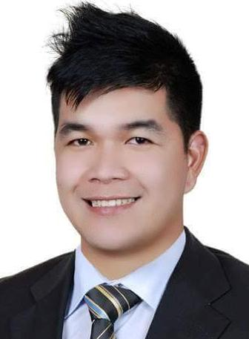

* To obtain a position that will enable me to use my knowledge, skills, and abilities to work well with people.
* To become an asset of the company that I will be working with.



* Hardworking, energetic, flexible and can easily adapt to change of environment and work schedule
* Maintain critical thinking skills essential in providing competent and dignified patient care.
* Personable with a positive attitude and can interface well with others.



Date of Birth : 7-September-1988

Place of Birth : Dangan Reina Mercedes, Isabela, Philippines

Age : 27 years old

Gender : Male

Nationality : Filipino

Civil Status : Single



**Bachelor of Science in Nursing**

University of Perpetual Help System -Cauayan Campus

April 2010



* May 2013 to Present Spa and Recreation Receptionist

Danat Hotels Resorts

Channel St, Dubai Rd near Alraha Mall, UAE

* April 2010 to March 2013 Casual Nurse

Cauayan District Hospital Philippines