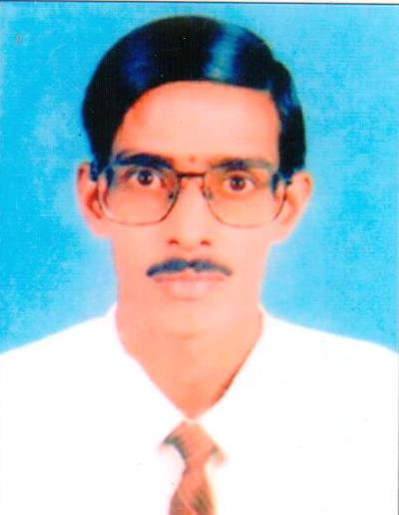
Viswanath Gurunath
Pharmacist/Medical Transcriptionist
Address:

#234, 2nd A Main, 11th Cross, 1st Block. B.E.L. Layout
Vidyaranyapura, Bangalore – 560097
Karnataka, India.

Contact Details:
+91 98 45934899(M) (India)
+971 543177891 (Dubai)
+91 80 23643809 (Landline)

Date of Birth: April 12th 1967
PERSONAL SUMMARY
A motivated pharmacist with a real passion for healthcare and the ability to develop and grow a pharmacy business. Experienced in maintaining administrative records such as pharmacy files / patient profiles and in providing excellent customer care by accurately dispensing prescribed medications by calculating, weighing, measuring, and mixing ingredients. Able to advise patients on medication brands, medication storage, medical equipment and health-care supplies.

Registered life time with Karnataka State Pharmacy Council.
Currently looking for a suitable pharmacist vacancy in a modern well equipped pharmacy.
WORK EXPERIENCE
- Own Pharmacy (Retail and Wholesale), 1993 to 2002.
- Worked as a Medical Representative for 3 years.
- Pharmacist, Indian Institute of Science Health Center, 2002 to 2004.
- Sr. Medical Transcriptionist at Heartland Transcription Services from 2004 to 2006.
- Sr. Pharmacist, Kethams Hospital, Bangalore, 2009 to April 2015.
- Sr. Medical Transcriptionist, Mmodal Global Transcription Services from 2006 to date.

Responsible for the day to day running of the Pharmacy.

Providing a professional sympathetic and supportive service to patients and identifying the right healthcare solution to meet their needs.

Willing to work in any shifts assigned. Very honest and punctual in tasks assigned to me.

Friendly nature to deal with the customers.

Able to work extra hours in case of emergency or if any staff is on leave. Maintain cleanliness in the pharmacy. Ready to relocate to any location within a short notice.

As I am working as a medical transcriptionist right now, have gained extensive knowledge about drugs and medical terminologies.

Duties:
- Accurately dispensing drugs to patients according to a doctor’s prescription.
- Checking prescriptions for errors & making sure they are appropriate for patients.
- Measuring, packaging, labeling and recording medications issued to patients.
- Instructing patients on how to use medications, possible side effects and storage.
- Contacting and working closely with other healthcare professionals.
- Answering questions from patients and staff about medicines.
- Ensuring the accuracy of all prescriptions, products and services supplied.
- Helping to develop the pharmacy's electronic discharge system.
- Managing and resolving complaints.
- Talking to regular patients to see how their treatment is going.
- Able to train and supervise Pharmacy Assistants.
- Communicating with customers sympathetically and supportively.
- Giving private consultations when required.
- Maintaining pharmaceutical stock, creating inventories and ordering more drugs.
- Have gained good knowledge of managing a hospital pharmacy
- Sr. Medical Transcriptionist, Mmodal Global Transcription Services from 2006 to date
- Well experienced in medical transcription with good knowledge of medical terminologies. Having good experienced in transcribing reports of all work types with a very good accuracy.

KEY SKILLS AND COMPETENCIES
- Keeping up to date with developments in the pharmaceutical industry.
- Experience of providing medicines management support to GP practices.
- Able to provide quality face to face customer interaction.
- Can work late evenings and weekends consistent with pharmacy opening hours. Willing to work overtime in case of emergency.
- A thorough understanding of various drugs and how they react in humans and with each other.
ACADEMIC QUALIFICATIONS
Pharmacy Diploma
Bangalore University 1992

REFERENCES
Dr. C.N. Dayananda.
Phone: +91 9900150656 (India)
Other references available on request.

