 | LIBU  Libu.312004@2freemail.com | 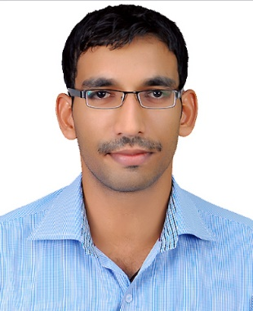

Professional Summary
- Highly motivated, focussed and energetic Mechanical Engineering graduate with ongoing 2year 6 months of experience in Engineering, project management and Maintenance in UAE consolidating total of 3year 5months professional experience after graduation. Hands on experience in Project execution in MEP, Facility management and Maintenance with site handling and able to work in deadlines and targets thereby coordinating with fellow colleagues. Successfully coordinated operations with major consultants, contractors and reputed hotel groups.

Education
BACHELOR OF ENGINEERING, MECHANICAL (2008-2012)
- ANNA UNIVERSITY, CHENNAI, TAMIL NADU, INDIA
- Aggregate score of 8.38 securing 1st rank among the department
- Secured 42nd rank in ANNA University out of 1559 candidates graduated
HIGHER SECONDARY EDUCATION(2008)
- KERALA SCHOOL, NEW DELHI, INDIA
- Secured 75% CBSE Board

Experience
PROJECT ENGINEER (08-04-2014 –Present)
FOURWINDS BUILDING CONTRACTING LLC (AL NUIMEYA, AJMAN)
- Coordination with consultant, client, Main contractors and sub contractors
- Negotiating contracts with vendors while ensuring continuation and enhancement of services.
- Maintain records relating to quality, quantity and progress of works.
- Chase the site staff to complete the project as per the target program and in budget cost.
- Ensuring resources being utilized effectively thereby ensuring safety and quality as per the company standards.
- Ensure correct reporting of project status to the top management regarding the status and progress of works.
- Hands on knowledge of Civil and MEP related works for swimming pool and water features.
- Professional knowledge in Planning, coordinating and controlling the facilities management
- Ensure compliance with safety, health and Environment requirements.
- Attending new site enquiries and preparing a competitive quote as per the site visit and requirements.
- Front led various projects with reputed clients including CPD ( CROWN PRINCE OF DUBAI-ROYAL VILLA ), EMAAR Management LLC, EJADAH Facilities Management, EMRILL Integrated Facilities Management, Desert Leisure LLC, MAB Facilities Management, PROSCAPE LLC.
- Successful execution of many contractual projects with reputed STARWOOD AND MARRIOTT Hotel Groups including LEMERIDIEN HOTELS, RITZ CARLTON, MARRIOTT HOTEL, JEBEL ALI HOTEL GROUPS.
GRADUATE ENGINEER TRAINEE (21-11-2012 to 31-10-2013)
RPC PAPER MILLS PRIVATE LIMITED (KERALA, INDIA)
- Handling maintenance schedules and work order allotment.
- Attended and assisted breakdown and preventive maintenances.
- Carrying out preliminary checkups over the operational requirements, procurement and management.
- Reporting to top management regarding day to day activities and production reports.
- Mechanical working along with fellow colleagues thereby gaining knowledge and hands on experience.
- Understanding the working process from the raw material to the end product.
Technical Expertise and skills
- Certification of QA/QC engineer (welding/piping)
- ASNT LEVEL II NDT certification in Non Destructive testing .
- Certification in Six Sigma, quality management paper.
- In Plant training in Sothern railway, India on “ Air Boggie Braking System of a Train”
- Planning and task management skills.
- Flexible and smart worker with pleasant personality.
- Team worker and coordinates in finding feasible solutions.
- Good sportsmanship and holds many medals and certificates.
- Holds GCC DRIVING LICENSE valid till APRIL 2025

Software Knowledge
- Autocad
- MS Office
- Solid Works
- ANSYS

Date of Birth : 19-04-1991
Nationality : Indian
Marital Status : Single
Languages Known : English, Hindi, Malayalam, and Tamil
I declare that the above information is true to the best of my knowledge.

REFERENCES – Available on request.

