NERWIN, CPA

CAREER OBJECTIVE

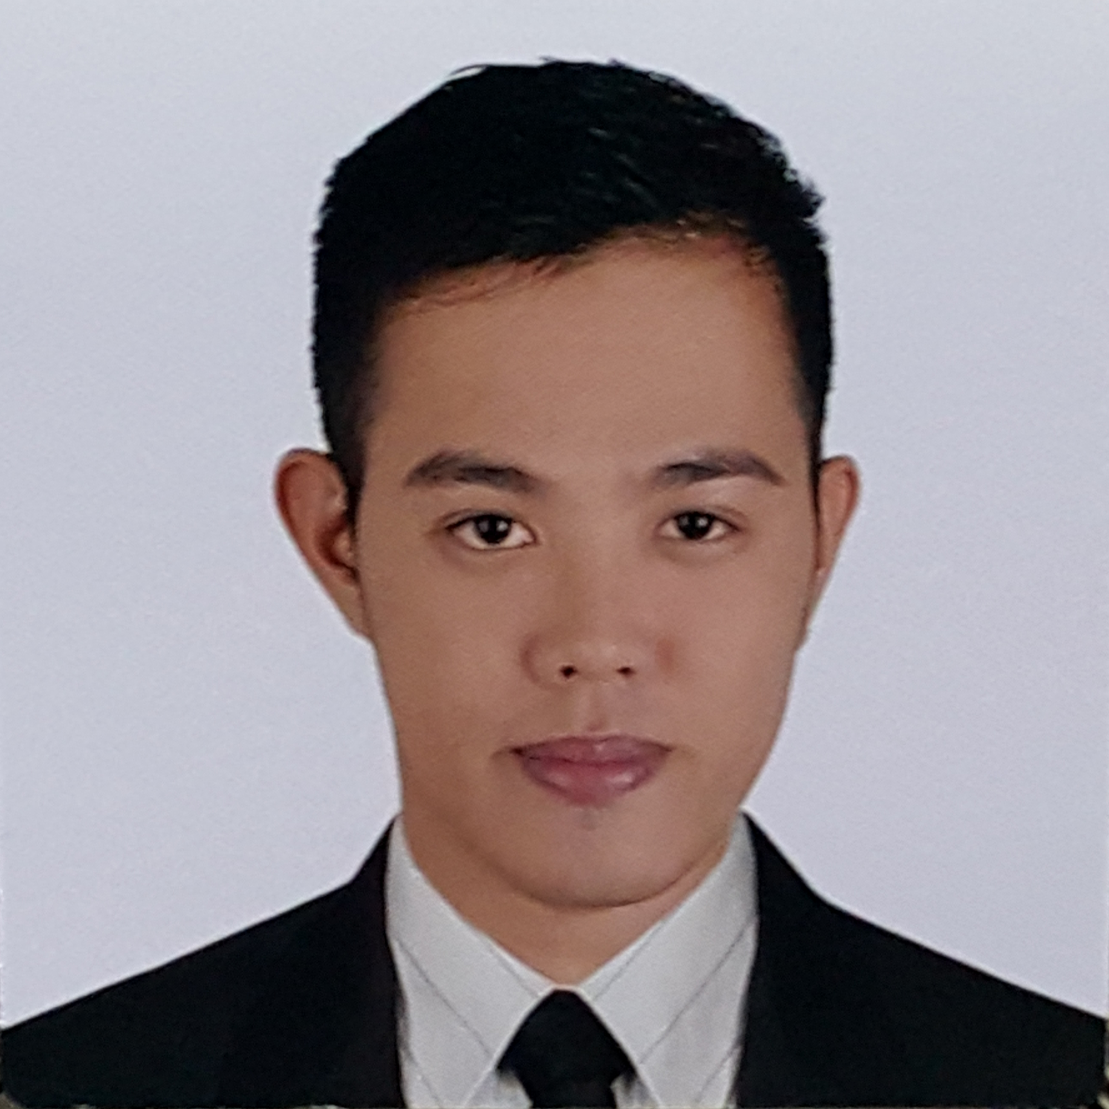

Email: nerwin.312008@2freemail.com

Age: 27

Birthdate: November 13, 1988

Civil Status: Single

Gender: Male

Citizenship: Filipino

Language: English and
Filipino

To passionately contribute my global experience, knowledge, skills acquired through more thanfive (5) years of solid work experience as an auditor. To deliver technical excellence, exceptional client service and proactively present high-value insights that is relevant to clients’ business profile and needs.

SUMMARY OF QUALIFICATION

- International Financial Reporting Standards certified
- Have long experience dealing with foreign clients engaged in manufacturing industries and has good communication skills both written and oral having dealt with various professionals and colleagues.
- A team player and have displayed good coaching skills to junior staff.
- A fast learner, diligent and can multi task having handled various out of town engagements with same timetable and early deadlines.
- Capable of adapting to changes having the experience to work with five Audit Partners.
- Respond well to fast-paced and high pressured environment and can work with minimal supervision.

PROFESSIONAL EXPERIENCE

Deloitte &Touche
Doha, Qatar
Senior Auditor–Financial Accounting and Assurance Services
February–June 2016
- Schedule, conduct and organize audit engagements which include industry and business risk analysis and evaluation.
- Understand client internal control system which includes evaluating the design and implementation of internal controls, and performing test of control.
- Design and perform audit procedures on identified business process.
- Prepare and complete the financial statements.

EY(Ernst & Young)
Makati, Philippines
Senior Associate –Financial Accounting and Assurance Services
October 2013 - November 2015
- Perform high level understanding of the client’s business and relevant critical processes to identify significant improvement opportunities.
- Performs assessment of the involvement of other service line in the engagement and coordinate with them for the accomplishment of the engagement.
- Serve as one of the key contact to the client.
- Supervises and administers staff in audit fieldwork and performs direct and timely performance feedback to the staff. Acts as a coach and mentor to all subordinates.
- Reviews own work and perform detailed review of work of others to ensure that work is complete, technically accurate, properly performed and adequately documented with exceptions, differences and issues appropriately addressed.
- Analyze complex audit issues identified, formulates conclusion and presents research findings to engagement executives for approval.
- Active participation along with the engagement manager and partner during discussion of audit results with the client.

PROFESSIONAL EXPERIENCE (continuation)

EY (Ernst & Young) (continuation)
Senior Associate –Financial Accounting and Assurance Services
October 2013 - November 2015
- Prepare and finalize financial statements and management letter comments.
- Perform cluster and engagement administrative works such as monitoring of cluster budget and planning resources, planning cluster staff allocation throughout the audit year, counsel assigned junior staff and cascading information for cluster events.

Associate –Financial Accounting and Assurance Services
December 2010 - September 2013
- Performs understanding of the Company’s business as well as its significant processes to identify significant areas for improvement.
- Prioritizes business risks and internal control weaknesses and formulates recommendations on the enhancement of such processes.
- Executes substantive audit procedures and test of controls as set forth in the audit program.
- As in charge associate, supervises and reviews the work of other staff.

INDUSTRY EXPOSURE AND SPECIALIZATION

Experience in the financial services industry
- Financial audit of a quasi-government bank in the Philippines
- Audit for an asset management company in the Philippines
- Conducted financial statements consolidation workshop on asset management accounting team

Extensive experience in non-financial service industry
- Audit of automotive manufacturing companies, technology, service, leasing real estate and other core industries
- Performed various agreed-upon procedures as compliance to government regulatory bodies for request in increase in authorized capital stock and bond offering.
- Performed agreed-upon procedure aimed to reconcile management income against financial reporting income
- Performed agreed-upon procedure aimed to review prior year audited balances and workingpapers of previous auditors in accordance with the acquisition procedures of the acquiring Company

LIST OF AUDIT CLIENTS (NOT EXHAUSTIVE)

Asset Management
- NBK Holding Company, W.L.L.
- JAKA Investments Corporation

Banking industry
- Armed Forces of the Philippines Savings and Loans Association, Inc.

Construction industry
- H Deco Qatar W.L.L.

Manufacturing industry
- First Sumiden Circuits, Inc. (Top 300 Company in the Philippines)
- PilipinasKyohritsu, Inc. (Top 300 Company in the Philippines)
- Pacific Royal Basic Foods, Inc.
- Casilayan Softwood Development Corporation

Not for profit industry
- De La Salle John Bosco College, Inc.

Power distribution industry
- DMCI Masbate Power Corporation

LIST OF AUDIT CLIENTS (NOT EXHAUSTIVE) (continuation)

Real estate industry
- Sta. Lucia Realty Development Inc.
- Amorsedia Development Corporation
- HLC Development Corporation

Retail industry
- Redington Qatar W.L.L.

Service industry
- Doha Industrial Safety Services W.L.L.
- NBK International W.L.L.
- Philippine Integrated Energy Solutions
- Directpower Services, Inc.

EDUCATIONAL BACKGROUND

2006-2010 Rizal Technological University
Bachelor of Science in Accountancy
- Graduated Cum Laude(with honorary distinction)
- Academic Scholar, SY 2007-2010
- Dean’s Lister, SY 2007-2010

2002-2006 City of Mandaluyong Science High School
- Bookkeeper of the Year Awardee, SY 2005

TRAININGS AND SEMINARS ATTENDED

Assurance trainings:

- The Audit Excellence 2016 – Provides knowledge on International Accounting Standards updates which are to take effect starting January 1, 2016.
- 2015 IFRS 15 Enablement – Provides knowledge on IFRS 15, the new revenue recognition standard, and its impact on certain industries
- IFRS Executive Updates– Provides knowledge on selected IFRS updates to audit executives annually.
- Introduction to Asset Management –Focuses on the theories and basic concepts regarding the accounting and audit for clients in the Asset Management industry.
- IFRS Workshops: Financial Instruments, Group Accounts 1 - Business Combinations, Group Accounts 2 - Classification of Investments, Impairment of Assets, Intangible Assets and Share Based Payments, Introduction to Financial Reporting, Revenue Recognition, Income Taxes and Employee Benefits

Comprehensive training courses on audit methodology:

- Assurance Training - Advanced Senior Program. Enables the experienced seniors to explore their roles and responsibilities as they relate to ensuring quality and managing risks on an audit engagement. This program also covers fraud, but with an emphasis on mindset and professional skepticism rather than on technical knowledge.
- Assurance Training - Intermediate Senior Program. Intended to equip second year seniors with the relevant knowledge in relation to multilocation engagements, project management, effective communication with team members, identifying and managing risks and improving ability to exercise professional skepticism and judgment.

