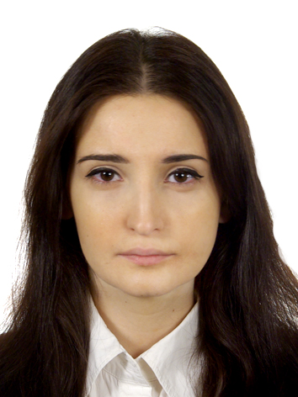 IYA
E-mail: Iya.312090@2freemail.com
Personal information:
Nationality: Russian
Place of residence: Dubai, UAE
Date of birth: October 9th, 1987
Education:
-January 2013 - December 2013
Master’s of Science in International Relations, ASERI (Postgraduate School of Economics and International Relations), Università Cattolica del Sacro Cuore, Milan, Italy (completely taught in English).
-September 2004 – June 2009
Master’s of Science in Translation/Interpretation (Russian, English and French), Moscow State Linguistic University, Moscow, Russia.
Professional Experience:
-March 2014 – now Nila & Monroy, Dubai, UAE
Personal assistant, logistics and events coordinator
Duties:
- Management of all staff, the oversight of all procedures and the troubleshooting of any problems,
- Overseeing operations of the venue,
- Support to meetings and travel arrangement,
- Management of documentation for business trips,
- Support in organization of the Queen of USSR 2016 event,
- Process and responds to upcoming events.

-October 2013-February 2014- The European Union Delegation to the Russian Federation, Moscow, Russia
Intern in the Transport, Energy and Environment Section
Duties:
- Contribution to the reporting activities of the Delegation with special attention to EU-Russia energy development,
- Analysis and research of the environmental and transport situation in the country by monitoring local press coverage,
- Preparation of detailed internal reports as directed and assisted in press and information activities when required,
- Preparation of daily briefings for the Headquarters at Brussels on the current situation as well as draft background notes,
- Analysis of data attendance and support to various meetings, conferences at the ministries and preparation of the meeting minutes.
- February 2012 - December 2012 - Sibex Oil limited (British oil company) Moscow, Russia.

Personal assistant
Duties:
- Office management, meetings arrangement, coordination of the companies’ participation in offshore Oil & Gas industry working groups,
- Logistics, planning and organization of meetings,
- Managing of small projects with foreign business partners,
- Participation in negotiations/business delegations abroad,
- Preparation of funding applications and commercial reports,
- Collecting, processing and analyzing data,
- Project estimation, project management support.
- August 2011 - December 2011- Ernst & Young CIS B.V. Moscow, Russia

Executive Assistant in Transaction Advisory Services
Duties:
- Administrative support to senior managers, logistics and travel support,
- Detailed annual work plans preparation, analyzing data, reporting including budget, resources, and management of documentation for business trips,
- Controlling of the legality and regularity of financial transactions,
- Organization and monitoring of the activities and the deadlines.
- September 2009 - May 2011- Kad-M Association (Moscow, Lisbon)

Event planner
Duties:
- Researching markets to identify opportunities for events;
- Liaising with clients to ascertain their precise event requirements;
- Producing detailed proposals for events (e.g. timelines, venues, suppliers, legal obligations, staffing and budgets);
- Agreeing to, and managing a budget;
- Securing and booking a suitable venue or location;
- Ensuring insurance, legal, health and safety obligations are adhered to;
- Coordinating venue management, caterers, stand designers, contractors and equipment hire;
- Organizing facilities for car parking, traffic control, security, first aid, hospitality and the media;
- Identifying and securing speakers or special guests.

Language skills:Mother tongue: Russian, English (excellent), French (excellent), Italian (advanced); TOEFL iBT – 103 (test passed in 2012)

Computer Skills: Proficiency in Microsoft Office tools (Outlook, Power point, Word, Excel, Visio, SharePoint, MS Project), iOS, Lotus Notes, Internet, Trados, SQL database.

