SANDEEP
e-mail: sandeep.312493@2freemail.com 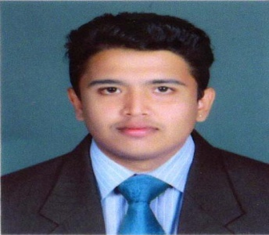

CAREER OBJECTIVE:
Dedicated professional seeking a position that would enable me to broaden my current skills and challenge my various abilities in Engineering-Electronics and Communication environment. Self-motivated and goal-oriented, with an ability to prioritize in a multi-task environment. Strong organizational, interpersonal and communication skills. Looking for an organization that offers career growth and a chance to achieve goals through persistence and hard work.
ACADEMIC QUALIFICATIONS

Course | Institution | University/Board | Year Of Passing | CGPA / Percentage
B.Tech – Electronics & Communication Engineering | College of Engineering & Management  Kerala,India. | Kerala University | 2015 | 6.86
Plus-Two (XII) | T.D.H.S.S. Alleppey, Kerala,India | Kerala State Board | 2011 | 87.5
AISSE (X) | Chinmaya Vidyalaya, Alleppey,Kerala,India. | C.B.S.E | 2009 | 85

TECHNICAL SKILLS

System Software : C++, MATLAB, MICROCONTROLLER
Operating System : Windows

MINI PROJECT
Topic : Automatic Power ON Timer

Description : Automatic Power ON Timer supplies power to a load at desired time which can be set by the user. Using this project we can switch ON any appliances in our house at pre-set time. The time can be set by using the alarm of alarm clock.

MAIN PROJECT
Topic : LED Lighting System Using DC Power Line Communication

Description : Our conventional lighting system in our premises need individual electrical wirings to establish the connection from switch board to light and there is no degree of freedom over the control of brightness of light. In this project we can control the brightness of lights, by just using two wires i.e; all the lights are connected parallel to these two wires from switch board and each light can be operated independently. LED lights are used so that efficiency is high. 18 volt dc supply is used so that electric shock can be avoided. Battery backup is provided in case of power failure.

CO-CURRICULAR ACTIVITIES

- Participated in AutoBotz-AVR, a workshop conducted by Technophilia Systems in association with Robotics & Computer Applications Institute of USA held at College of Engineering & Management, Alleppey,Kerala, India.

PERSONAL DETAILS

Date of Birth : 12th January 1993
Visa Status : Transferable
Nationality : Indian
Marital Status : Single
Language known : English, Hindi, Malayalam,and Konkani

