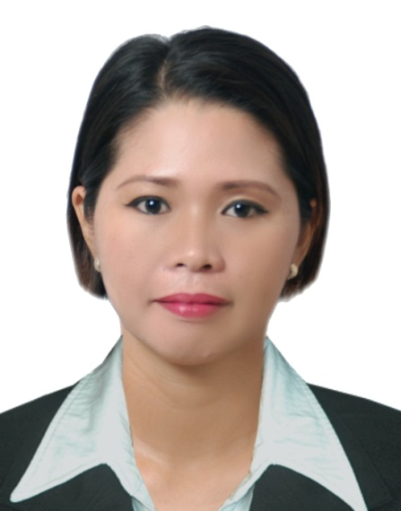
RITCHEL
RITCHEL.312585@2freemail.com

Professional Summary

Dedicated and proactive individuals effective front desk and customer service experience. Demonstrated ability to maintain a pleasant, positive, and courteous demeanour continually.
• Well-versed in greeting visitors, scheduling appointments
• Positive attitude and disciplined work ethic
• Adept at answering phones, faxing, and filing
• Computer savvy: Proficient in MS Office (Word, Excel)
• Bilingual: English and basic Arabic ; enjoy working with diverse people and able to multi-task
Professional Experience
Front Desk Receptionist October 2014- September 2015
JWA GROUP, DUBAI UAE
- Reorganize the visitor check in/out procedure by introducing an automated identification system
- Greet visitors, guests and customers as they arrive
- Provide information asked for and direct them to the right departments
- Assist visitors and customers to the right staff member
- Handle telephone calls and direct them to the right recipient
- Distribute incoming mail and manage outgoing correspondence
- Schedule meetings and conferences
- Hand out employee application, memos and notices
- Prepare correspondence and documents
- Maintain appointment diary either manually or electronically
- Monitor and maintain office equipment
- Control inventory relevant to reception area
- Tidy and maintain the reception area
Hostess/Cashier December 2013- August 2014
The Meydan Hospitality, DUBAI UAE
Bab Al Shams Hotels and Resort
- Greet guests and patrons personally as they enter into the establishment
- Receive and record dining reservations on the telephone
- Ensure the proper setup of dining and service areas
- Offer appropriate seats using truly personable demeanor
- Politely request guests to wait in waiting area if no table is available
- Ensure neatness and cleanliness of stations
- Present menus, make recommendations and take orders
- Ensure the quantity of food is sufficient to cater to the number of guests
- Relay orders to the kitchen and ensure all orders are filled in a timely and accurate fashion
- Maintain clean and organized tables and work area
- Assist room service staff when needed
- Manage event related work including setting up tables and maintaining both exterior and interior of the restaurant
- Resolve guests’ concerns in a prompt manner
- Prepare food and beverages when needed
- Liaise between staff and customers to ensure great service
- Order table linens, napkins and other dining room supplies

Front Desk Receptionist November 2011 – November 2013
Advance Facilities Management, ABU DHABI UAE
- Receive, direct and relay telephone messages and fax messages
- Pick up and deliver the mail
- Open and date stamp all general correspondence
- Maintain the general filing system and file all correspondence
- Assist in the planning and preparation of meetings, conferences and conference
- telephone calls
- Make preparations for Council and committee meetings
- Maintain an adequate inventory of office supplies
- Respond to public inquiries
- Provide word-processing and secretarial support
- Perform clerical duties in order to maintain office operation
- Develop and maintain a current and accurate filing system
- Monitor the use of supplies and equipment
- Coordinate the repair and maintenance of office equipment

Receptionist March 2008-May 2011
Proline Parties, Dubai UAE
- Prepare and manage correspondence, reports and documents.
- Distribution of memos to the staff.
- Implement and maintain office systems.
- Maintain schedules.
- Arrange and confirm appointments.
- Handle incoming mail from different hotels.
- Receive payment from the hotels.
- Created and maintained computer- and paper-based filing and organization systems for records, reports and documents.
- Coordinate the flow of information both internally and externally.
- Investigated issues and problems from the staff.
- Wrote and distributed meeting minutes to different hotels.
- Process travel expenses and reimbursement requests.

Data Encoder November 2005 – February 2008
MIS Provincial Capitol Iloilo City, Philippines
- Prepares source data for computer entry by compiling and sorting information; establishing entry priorities.
- Processes customer and account source documents by reviewing data for deficiencies; resolving discrepancies by using standard procedures or returning incomplete documents to the team leader for resolution.
- Enters customer and account data by inputting alphabetic and numeric information on keyboard or optical scanner according to screen format.
- Maintains data entry requirements by following data program techniques and procedures.
- Verifies entered customer and account data by reviewing, correcting, deleting, or reentering data; combining data from both systems when account information is incomplete; purging files to eliminate duplication of data.
- Tests customer and account system changes and upgrades by inputting new data; reviewing output.
- Secures information by completing data base backups.
- Maintains operations by following policies and procedures; reporting needed changes.
- Maintains customer confidence and protects operations by keeping information confidential.
- Contributes to team effort by accomplishing related results as needed.
Sales Associate April 1999-December 2003
BUM and CRIMSON Company, SM Iloilo Philippines
- Ensure high levels of customer satisfaction through excellent sales service
- Assess customer’s needs and provide assistance and information on product features
- “Go the extra mile” to drive sales
- Maintain in-stock and presentable condition assigned areas
- Actively seek out customers in store
- Remain knowledgeable on products offered and discuss available options
- Cross sell products
- Team up with co-workers to ensure proper customer service
- Build productive trust relationships with customers
Training
Essential Food Safety Training Certificate Syscoms College
Abu Dhabi Food Control Authority Date Expiry 10/07/2017
Education
Associate in Computer Technology
Iloilo State College of Fisheries SY: 2005-2006

Bachelor of Science in Electrical Engineering
Western Visayas College State Technology (Undergraduate)

