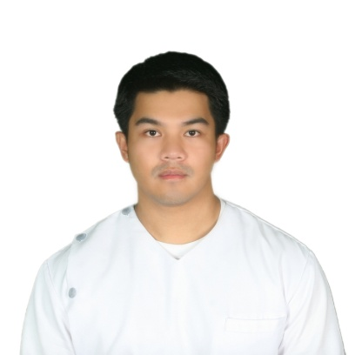
Cyrus

Cyrus.312622@2freemail.com

Objective

To be a competent worker at your good office, in which I can utilize and develop my skills and experience acquired in school and in hospital.

Education
COLLEGE:Saint Louis University, Baguio City: (BSE)
June 2000 – March 2001
Pines City Colleges, Baguio City: June 2001–April 2005
Course: Bachelor of Science in Nursing

- Registered Nurse: Passed the Nursing Licensure Examination Board for Nurses (December 3-4,2005).

- HAAD (Health Authority Abu Dhabi) PASSER (October 12, 2016)

ELEMENTARY: Pinsao Elementary School, Pinsao Pilot
Project, Baguio City: June 1990 – March 1996

SECONDARY: PCNHS, Pinsao Annex,
Baguio City: June 1996 – March 2000

Work Experience

SLU,Hospital of the Sacred Heart : September 21,2007
Baguio City, Philippines to Present
180 Bed Capacity
Staff Nurse
Areas of Exposure: Medical Ward, Surgical Ward/ICU, Coronary Ward, Medical ICU, Pediatric Ward, Pedia ICU, Private Room Annex 2

Cases Handled
- Medical Cases:
Hepatitis,Tuberculosis,Dengue,Meningitis, Emphysema,COPD,Adult Respiratory Disease, Leptospirosis, Kawasaki Disease, Systemic Lupus Erythematosus, Hyper/Hypothyroidism, Diabetes Mellitus, Diabetic Ketoacidosis, Guillain-Barre Syndrome, Upper and Lower Gastro Intestnal Bleeding(Hematochezia,Melena)
- Coronary Cases:
Myocardial Ischemia, Cerebrovascular Accident(Stroke), Cardiac Dysrythmias, Ventricular Tachycardia/Febrillation
- Oncological Cases:
Breast Cancer, Papillary Thyroid Cancer, Gastric Cancer, Pancreatic Ca, Ovarian Ca, Prostate Ca, Lung Ca, Bone Marrow Aspiration
- Surgical Cases:
Craniotomy, Craniectomy, Tonsillectomy, Caldwell-Luc Procedure, Tonsillectomy, Tracheostomy, Thyroidectomy, Chest Tube Insertion, Thoracentesis, Central Venous Insertion, Gastrectomy, Appendectomy, Colectomy, Colostomies, Ileal Conduit, Cholecystectomy, Transurethral resection of the prostate, Hemorrhoidectomy, Laminectomy, Amputations, Skeletal Tractions, Hip Fractures

Equipments Handled
- Pulse Oximeter
- Suction Apparatus
- Oxygen Regulator
- Nubulizer
- Defibrillator
- Cardiac Monitor
- ECG Monitor
- Mechanical Ventilator

Pines City Doctors’ Hospital : January 24, 2006 – April 15,06
Magsaysay Ave., Baguio City
Philippines
Nurse Volunteer

Saint Louis University : July 3, 2006 – August 3, 2006
Hospital of the Sacred Heart
Baguio City, Philippines
Nurse Orientee

Sto.Nino Jesus Medical Center Foundation,Inc.: December 3, 2006 – May 10,07
Areas of Exposure: Operating Room,Labor Room,Delivery Room
Baguio Central University
Baguio City, Philippines
Nurse Volunteer

SLU, Hospital of the Sacred Heart : May – July 2007
Baguio City, Philippines
Private Duty Nurse

Data Center College of the Philippines : May 15 – June 30,07
Affiliation at
SLU, Hospital of the Sacred Heart
Baguio City, Philippines
Clinical Instructor

Seminars Attended

Basic Life Support (AHA) : April 29, 2016

First Aid and CPR : September 5,6 and 7,2002

Surgical Emergencies : July 24, 2005
(Baguio city, Philippines)

Operating Room Protocols : February 5, 2006
(Baguio city, Philippines)

Sexual Disorders : August 20, 2006
(Baguio city, Philippines)

Myocardial Infarction and : August 20, 2006
Geriatric Emergencies
(Baguio city, Philippines)

Children with Special Needs : August 20, 2006
(Baguio city, Philippines)

Basic IV Therapy Training Program : October 16-18, 2009
(Baguio city, Philippines)

Basic CT scan and MRI : March 9, 2010
Interpretation
Early Detection of Stroke
Care of Stroke Patients
(Baguio city, Philippines)

Cardiovascular Essentials: : April 16, 2010
Basics and Beyond
(Baguio city, Philippines)

Basic Life Support and Cardiac : December 17-19, 2010
Life Support Course
(Baguio city, Philippines)

Stroke Assessment and Management : Sepetember 21, 2011
(Baguio city, Philippines)

Personal Data

Age: 33 y/o Date of birth: February 19, 1983
Gender: Male
Place of birth: Baguio City
Height: 5’4”
Weight: 70 kgs.
Civil Status: Married
Citizenship: Filipino
Languages: English, Tagalog, Ilocano

