ARUN.  EMAIL ID : arun.312652@2freemail.com | 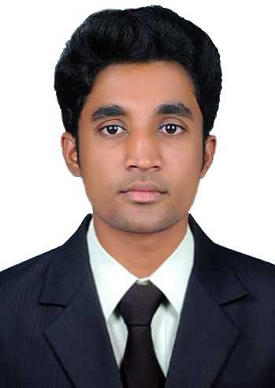

OBJECTIVE:

I am a focused, ambitious man seeking an opportunity to work with a reputable firm that will enable me utilize my skills for the benefit of the company.

PROFESSIONAL EXPERIENCE:
- Organization : MAS MAKE POLYMER (P) Ltd
Location : Palakkad, Kerala
Designation : Line Engineer
Duration : 03/08/2015 – 19/08/2016
Job Responsibilities:
- Supervising employees
- Production controlling and documentation
- Maintenance Management
- Quality checking
- Store keeping
- Safety management
- Organization : BU ENGINEERING & INSPECTION (P) Ltd
Location : Faridabad, New Delhi, India
Designation : Assistant QA/QC Engineer/Site Supervisor
Duration : 02/06/2014 – 19/06/2015
Job Responsibilities:
- Supervising employees.
- Production controlling and documentation.
- Study the pipe drawings and supervising the technicians and preparing the reports.
- Radiographic testing of oil and gas pipe lines welded joints, railway parts like brake drums, shoe & castings.
- Safety management.

TECHNICAL PROFILE:
Course | Year of Study | Name of the Institute | Name of the University/Board | Marks secured
B.Tech in Mechanical Engineering | 2011-2014 | Sree Narayana Mangalam Institute of Management andTechnology Maliankara | MG University | 60%
Diploma in Mechanical Engineering | 2008-2011 | Sree Rama Polytechnic College,Triprayar | State Board Of Technical Examination | 67%
HSE | 2006-2008 | National Higher Secondary School,  Irinjalakuda,Kerala | State Board | 84%
SSLC | 2005-2006 | St Mary’s Higher Secondary School,  Irinjalakuda,Kerala | State Board | 90%

SOFTWARE KNOWLEDGE:

- Software Skills : AutoCAD, MS office
- Operating System : Windows
ADDITIONAL QUALIFICATIONS:

- ASNT(NDT)Level II in Ultrasonic Testing,Radiographic testing,Liquid penetrant testing,Visual inspection & Magnetic particle testing.
- ASNT Level II in Welding inspection & Piping and PipelineEngineering
ACADEMIC PROJECTS:

- Automatic PipeCutting Machine(Engineering)
Automatic pipecutting machine using gas cutter which uses to cut steel pipes with great accuracy with accurate dimensions. The machine carries simple working principle. Evenunskilled workers can also operate the machine.

- Automatic Adjustable Bed(Polytechnic)
This project plays important role in hospital managementfor paralyzed patients.Ithelps to reduces human effort and saves the time.Our aim is to produce the product with low price.We have the confidence that our product will give new motivation to the hospital field.

ACADEMIC SEMINARS:

- Re-Entry of Space Vehicle (Engineering)
Re-entry capsules promises to intensify international competition in launch services, Microgravity research and space technology development.These systems will also confer an important strategic advantage in conduct of materials and in life science research.

- Micro Electro Mechanical Systems (Polytechnic)
MEMS are small integrated devices or systems that combine electrical and mechanical components.MEMS extended the fabrication techniques developed for the integrated circuit industry to add mechanical elements such as beams,gears,diaphrams,and springs to devices.

PERSONAL INFORMATION:

- Date of birth : 02/07/1990
- Gender : Male
- Marital Status : Single
- Nationality : Indian
- Visa Status : Visit Visa
- Language’s Known : English,Hindi,Malayalam
Passport Details:
- Place of issue : Cochin
- Passport issue date : 08/07/2011
- Passport expiry date : 07/07/2021
Driving license details
- Type : LMV, M/C with GEAR

PERSONAL SKILL:

- Committed, confident and hardworking with a positive attitude.
- A good survivor with strong desire to learn.
- Innovative and initiate ideas.
- A constant urge for smart working and learning.

DECLARATION:

I do hereby declare that the particulars of information and facts stated herein above are true, correct and complete to the best of my knowledge and belief.

ARUN.

