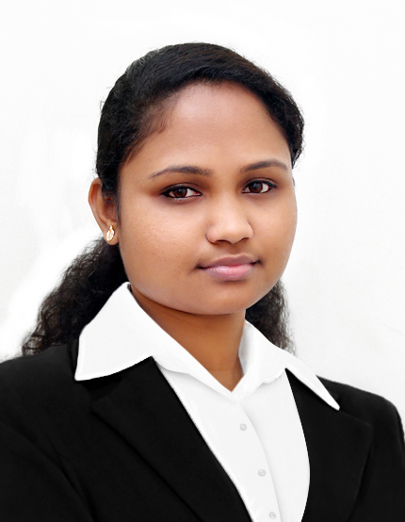

**Career Objective**



A highly competent, motivated and enthusiastic administrative assistant with experience of working as part of a team in a busy office environment. Well organized and proactive in providing timely, efficient and accurate administrative support to office managers and work colleagues. Approachable, well presented and able to establish good working relationships with a range of different people. Possessing a proven ability to generate innovative ideas and solutions to problems. Currently looking for a suitable position with a reputable and ambitious company.



**Work Experience**



|  |  |  |  |
| --- | --- | --- | --- |
| **INSTITUTION** | **:** | **University Of Calicut(2014-2016)** |  |
| **PERSONAL INFORMATION** |  | **KERALA-INDIA** |  |
|  |  |  |
| **POSITION TITLE** | **:** | **ADMINISTRATIVE ASSISTANT** |  |
| **Reshma** |  |  |  |
| **RESPONSIBILITIES** | **:** |  |  |

**LANGUAGE SKILLS**

English, Hindi & Malayalam

**SPECIAL SKILLS**

**AND APTITUDES**

Fair knowledge in Microsoft Office Computer Application and MAC OS

**AREA OF INTEREST**

Department Coordinator

Doing Office & Computer Works

Data Entry

* Event coordinating in university of Calicut.
* Meeting and greeting clients and visitors to the office.
* Typing documents and distributing memos.
* Supervising the work of office juniors and assigning work for them.
* Handling incoming / outgoing calls, correspondence and filing.
* Faxing, printing, photocopying, filing and scanning.
* Organizing business travel, itineraries, and accommodation for managers.
* Monitoring inventory, office stock and ordering supplies as necessary.
* Updating & maintain the holiday, absence and training records of staff.
* Responsible for purchase orders. Raising of purchase orders and invoice tracking.
* Creating and modifying documents using Microsoft Office.
* Setting up and coordinating meetings and conferences.
* Involvement in social media implementation. Updating, processing and filing of all documents.
* Handling Data Entry.
* To satisfy the customer needs.
* Entries of data in files and cross checking of books and datasheets.
* To help the technical supports.
* Attend calls professionally and transfer to individuals and departments.
* Oversee and supervising the work of junior office staff.
* Sourcing client entertainment, booking dinners and arranging offsite meetings.

**EDUCATIONAL BACKGROUND**

MSc. Computer Science From

Calicut University 2012

Kerala-India

**Course Graduated**

BSc. Computer Science From

Calicut University 2010

Kerala-India

**Course Graduated**

**PERSONAL DETAILS**

**DEC 24th 1989**

Date of Birth

**Kerala, India**

Place of Birth

**Married**

Marital Status

**Female**

Gender

**Indian**

Citizenship

**PERSONAL SKILLS**

Good Analytical, Problem solving skill, Creativity, Hardworking Nature, Good Communication skills, Highly trustworthy, discreet & ethical, Positive attitude, Multitasked, Willingness to learn.

**HOBBIES**

Music, Movies, Reading

|  |  |  |
| --- | --- | --- |
| **INSTITUTION** | **:** | **IDEAL PUBLIC SCHOOL KUTTIADY** |
| **POSITION TITLE** | **:** | **COORDINATOR** |
|  |  | **KERALA-INDIA** |
| **RESPONSIBILITIES** | **:** |  |
| * Organizing event management in school * Organizing repairs to faulty office equipment. * Setting up meeting rooms for visitors and management. * Handling school office work in MS Word, MS Excel etc..   **NSTITUTION** | : | **APTEC Computer Ltd** |
| **POSITION TITLE** | **:** | **ADMINISTRATIVE ASSISTANT** |
|  |  | KERALA-INDIA |
| **RESPONSIBILITIES** | **:** |  |

* Mailing, scanning, faxing and copying to management.
* Maintain electronic and hard copy filing system.
* Open, sort and distribute incoming correspondence.
* Perform data entry and scan documents.
* Manage calendar for Managing Director.

**Summary of Qualification**



* MSc. Computer Science from university of Calicut(2012), Kerala-India
* BSc. Computer Science from university of Calicut(2010), Kerala-India
* Higher Secondary education from Kerala state board(2007)
* High school education from Kerala state board(2007)

**Achievements:**



* Coordinator of Calicut University IT fest (Insight).
* Coordinator of Linux Club.
* Certificates in C, C++, ASP.NET with C#.
* Teachers training certificates in Computer Science and GK.
* Certificate in National Service Scheme.
* Participation Certificate in Eco-Friendly campaign in the Eco tourism area of Janakikkad.
* Head of Department in Computer Science.

**Relevant Information**



* **Office Management** 
  + Able to set and achieve timely documents, Transmittal of Documents across various departments and maintained confidentiality of the same.
* **Personal Attributes** 
  + Ample knowledge in basic computer applications useful in the Day-to-day office administration.
  + Honest, hardworking with professionalism, ethics and eye for details.
* **Leadership and Organization** 
  + Always initiated work in an atmosphere of volunteerism within the assigned department.
  + Motivated co-employees by always affording them support and assistance in their lines of work.

**Technical Details**

**Major project:**

* Nest E-Learning from Nest cyber campus, Trivandrum in ASP.NET with c#.
* E-Connect from Axle, Vatakara in ASP.NET with c#.

**Minor project:**

* Single window system from CAS Nadapuram (IHRD) in VB



**RESHM**

**Declaration**

I hereby declare that the above information is true to the best of my Knowledge and any reference required will be given later.