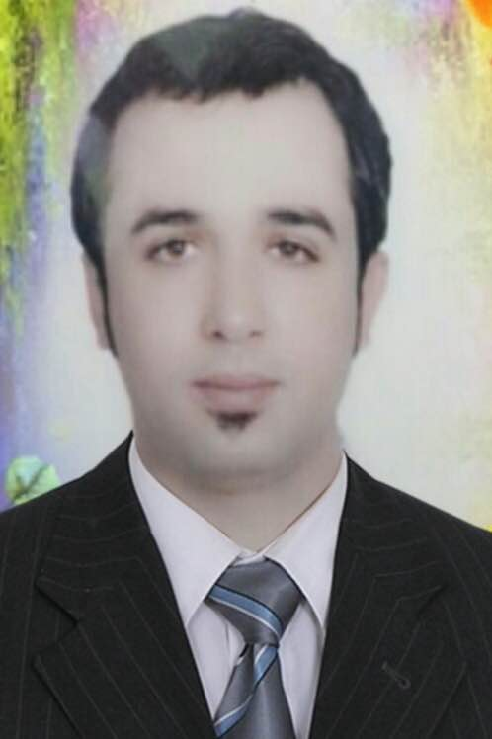
YAHYA
Email: YAHYA.312891@2freemail.com

OBJECTIVE
To take a challenging and high performance oriented role in my duties and service in my chosen career in areas related to my field and competence, provide growth for personal development and contribute to company’s success.

WORK EXPERIENCES

- Circle Restaurant – Supervisor – Al Ain (present)
- Restaurant Manager - Bon Appetite Restaurant – Fujairah
- Catering Supervisor - Manar Al Sham Company – Al Ain
- Supervisor - Dubai Marine Resort and Spa Hotel – Dubai
- Catering Supervisor – La Cucina Company – Abu Dhabi
- Supervisor - Cedar Lounge Fairmont Bab Al Bhar – Abu Dhabi

DUTIES AND RESPONSIBILITIES

-Following the Restaurant Operating Standards conducted by the company.
-Facilities must be 100% operational from the exterior, interior and all aspects of trade dress and organization. Ambiance must be maintained appropriately and appealing to the guest.
-Checking all plates, silverwares and glasses are appropriate stocks at all, in good repair, clean and available all matching to the brand specifications. Menus must be in good repair, clean and available at all times.
-Before each shift there must be a shift meeting to set daily standards, communicate daily specials, target and solve any pending issues.
-Products should be according to the approved product list, with enough stock, proper quality, properly stored, FIFO in place and expiry dates always be updated.
-Service must serve beyond the expectations of the guest. Always visit the tables and check back.
-Managers must be on the floor at peak times, visible, engaged and leading the team to provide proper service, food and experiences
-Must be knowledgeable about business sales, sales goals, performance history, budget target and results. Should be familiar with the location, business environment, their competitors and what is going on the market. Most of all, cost control in place and utilized.

EDUCATION Diploma of Hotel Management 2005
Institute of Tourism, Syria

(Seminars and Training Attended)

PERSONAL INFORMATION

Date of Birth: May 5, 1984
Nationality: Syrian
Status: Married

