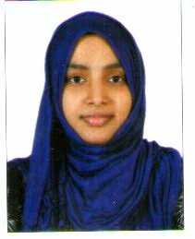 CURRICULUM VITAE
NASEELA
E-mail: NASEELA.313001@2freemail.com

Career objectives
To be the part of an Organization which uses my skills and expertise in its process of growth and change while giving me opportunities to learn and enrich my competencies.
To be build up a career in a challenging and demanding technological and creative environment, with the people in the establishment, that would help me to realize my potential and use my abilities in the most effective manner

Personal & Professional Profile
- Degree in CHEMISTRY.
- Planned and systematic approach to work.
- Familiar with Microsoft Office Applications and PC Skills
- Ability to work effectively from team environment, as well as take ownership for individual assignments
PROFESSIONAL EXPERIENCE
Since 2010-2011
Employer APTECH COMPUTER EDUCATTION
Job Title Admin assistant
Job responsibilities:
• MS word MS excel processing;
• dealing with telephone and email enquiries;
• creating and maintaining filing systems;
• scheduling and attending meetings, creating agendas and taking minutes - shorthand may be required;
• keeping diaries and arranging appointments;

Key Competencies:
- communication skills - written and verbal
- planning and organizing
- prioritizing
- attention to detail and accuracy
- flexibility
- teamwork

Educational Qualifications
- Bachelors of Science in Chemistry with 79%
(2009 -Calicut University, India)
- HSC in 2004 with 75%
- SSLC in 2002 with 63%
Computer Skills
- Post Graduated Diploma in Computer Application. (PGDCA)
- Microsoft office Suit, Internet & Outlook
Languages known
English, Malayalam and Hindi & Arabic

Personal Details
Nationality : Indian
Date of Birth : 02-02-1989
Sex : Female
Interest : Shopping, Cooking, Reading, Music, Etc.
Marital Status : Married
Visa Status : Resident Visa

Attributes:
Hardworking, Result Oriented, Confident.

