Dear Sirs,

Kindly find below my resume vitae applying for a new suitable position through your esteemed establishment, wishing it will meet the standards and requirements.

For over 13 Years now I've been working in the hospitality industry, most of them I've spent in the well-known Hotels with Hilton,

As well organized self-motivated, enthusiastic & quite aware with wide range of experience in both large and medium hotels & resorts in Middle East; having a farfetched competence & aptitude through working with multi-nationalities inland & abroad.

I assume my flexibility to work at different levels even if lower than my last position.

I'm currently working as Front Office Supervisor at Riviera Hotel Dubai.

SPECIALTIES:

- Rooms Division Experience

- Resorts Management

- Hotel Management

- Compounds / Facilities Management

- F & B Experience

- Night Auditing Experience

- Revenue Management.

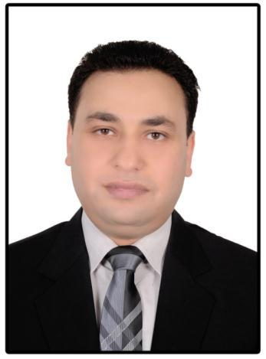
MOSTAFA

MOSTAFA.313189@2freemail.com

ACADEMIC PROFESSIONAL ATTAINMENT

Bachelor degree in Tourism &Hotels Hotel Management

Department

Helwan University 2002

LANGUAGE.

Arabic: Mother Tongue

English: Fluent

Italian: Very Good

Russian: Fair

LANGUAGE COURSES

English: Two levels (7&8) American University in Cairo.

Italian: Three levels (1&2&3) I.I.C.C.Italian Embassy

WORK EXPERIENCE.

*Riviera Hotel Dubai

From October 2015 till now

Front Office Supervisor

*Carols Beau Rivage Marsa Matrouh "5 Stars hotel" From March 2012 till June 2015

Assistant Front Office Manager & Reservation Manager in charge

*Hilton Sharm El Sheikh Fayrouz Resort.

From September 2009 till February 2012.

Front Desk Supervisor.

*Hilton Sharm El Sheikh Fayrouz Resort.

From November 2007 September 2009.

Front Desk Shift Leader.

*Hilton Sharm El Sheikh Fayrouz Resort.

From March 2005 till October 2007.

Front Desk Agent.

*Reef Oasis Beach Resort -SSH "5 Stars Hotel" From March 2003 till February 2005.

Front Desk Agent.

PRACTICAL TRAINING.

- Cairo Sheraton Hotel. July 2000 till September 2000 "Food Beverages"

- Helnan Shephard Hotel.July 2001 till September2001 "Front Office"

HILTON UNIVERSITY COURSES

*Hilton HHonors Guest manager And Front Office Training.(16 Levels) *Sales & Marketing.

*Leisure of Selling.

SKILLS/ABILITIES.

1-Microsoft Office Suite (Word /Excel)

2-Fidelio 6.20 (25) (Suite 8) /OnQ System

3-Use of internet (Microsoft Internet Explorer)

4-GroupWise.Outlook

DUTIES/RESPONSIBILITIES.

*I have the full responsibility of the hotel site & the entire internet booking (booking.com, etc)

*Cooperate, coordinate and communicates with other hotel department as required. *Fully conversant with all hotel emergency procedures.

*Check billing instructions and monitors guest credit.

*Check all correspondence for following day's arrival ensuring all requests are met and rooms are correctly assigned.

*Maintains guest accounts and charge record, back up are cleared on daily basis.

TRAINING SESSIONS.

*Handling guest complains. *Social skills.

*Hilton Brand Service standard.

*Up selling Strategy to achieve the maximum revenue *Front Office Operational.

*Emergency evacuation procedures.

PROFESSIONAL PROFILE.

*Strong interpersonal, excellent team player with good communication skills. *Ability to learn quickly. Adapting to changing conditions.

*Hard worker.

REFERENCES.

Furnished upon request.

I am looking forward to meeting your expectation and to join your teams

