CURRICULUM VITAE
Name  NARMATHA  DHA- RN CERTIFIED  E-Mail:  Narmatha.313258@2freemail.com  Passport Details:  Place of Issue: Cochin  Date of issue : 07/09/2012  Date of expiry: 06/09/2022  Languages Known:  English,Hindi,Malayalam&Tamil  Personal Data:  DOB:17/02/1988  Sex :Female  Nationality:Indian  Marital Status:Married | 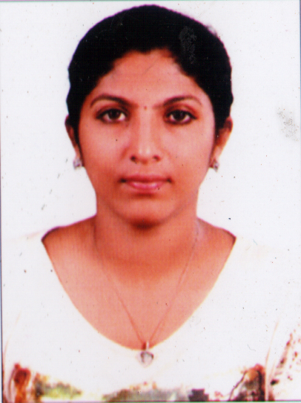  OBJECTIVE  To place myself in responsible and challenging position and to employ my experience and skills in a progressive organization,whereby I can put maximum efforts and prove my skills to attain the heights in the job profile provided.  PROFESSIONAL EXPERIENCE  Registered nurse with six years experience in clinical setting providing  Nursing care to diverse population. Enthusiastic and excellent people  Skills and dedicated work ethic.  1.SRI AUROBINDO MEDICAL COLLEGE,INDORE,MP,INDIA.  (12OO BEDED)  Designation : Staff Nurse in emergency dept.  Duration :26/12/2009 to 20/02/2015  2.PUSHPAGIRI MEDICAL COLLEGE,THIRUVALLA,KERALA,INDIA  (1200 BEDED)  Designation : Staff Nurse in neurosurgical icu .  Duration : 15/06/2015 to 06/07/2016  KEY STRENGTH  * Profound knowledge of general nursing and critical nursing  * Can assist for diagnostic, therapeutic procedure and pharmacologic treatment of health problem.  * Proficiency to educate patients and their families in compliance with the  hospital rules and regulations,patient rights etc.  *Ability to prioritize and develop plans accordingly.  *Strong managerical and organizational ability  * Multi tasking ability not compromising with the quality of work
S

DUTIES AND RESPONSIBILITIES

* Assisting in the supervision and development of health assistants

*Assessing the care needs of patients.

* Development,implementation and evaluation of programmes of care

* Reporting to senior managers.

ACADEMIC PROFILE

BACHELOR OF SCIENCE IN NURSING

DURATION : 4 YEARS FULL TIME(2005-2009)

AWARDING BODY : RAJIV GANDHI UNIVERSITY OF HEALTH SCIENCES, KARNATAKA

INSTITUTION : KALANIKETAN COLLEGE OF NURSING, KARNATAKA, INDIA

HIGHER SECONDARY EDUCATION

DURATION : 2 YEARS FULL TIME (2003 TO 2005)

AWARDING BODY : BOARD OF HIGHER SECONDARY EXAMINATION KERALA, INDIA

INSTITUTION .ST.MARY’S GHSS,KAYAMKULAM,KERALA

SECONDARY EDUCATION

YEAR : 2003

AWARDING BODY : KERALA STATE BOARD OF SECONDARY EDUCATION.

INSTITUTION : ST.MARY’S GHSS,KAYAMKULAM,KERALA.

COMPUTER PROFICIENCY

* Familiar with Windows 10

* M S Office

* Internet Surfing and E-Mail Operations

ADDITIONAL PROGRAMMES

* BLS (BASIC LIFE SUPPORT)
*ACLS(ADVANCED CARDIO VASCULAR LIFE SUPPORT)

PROFFESIONAL REGISTRATION AND MEMBERSHIP

- Kerala Nurses and Midwives council,T V M

Date of Registration : 31/10/2012

- Karnataka Nursing Council

Date of Registration : 11/01/2012

SKILLS

* Thorough physical assessment
* Patient positioning
* Feeding assistance
* Tracheostomy care
* Foleys catheter insertion / removal
* Insulin medical assistance
* Proper catheter insertion / removal
* Venipuncture / blood draw expert
* Professional bed side manner
* Dedicated hospice care provide
*Qualified lad result evaluator
* Strong judgement
* Palliative care awareness

PROFESSIONAL DECLARATION

I hereby declare that the information given above is true and correct to the best of my knowledge and belief.I will do my very best if placed in your esteemed institution

NARMATHA

