SUNITHA
SUNITHA.313521@2freemail.com 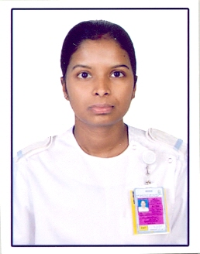
ASSISTANT NURSE

OBJECTIVE
To able to provide quality professional nursing care in the course of efficient implementation of contemporary knowledge and proficient skills.
QUALIFICATION
Nursing assistant course (2 year) - june2006
(Ambedhkarcollege of medical technology) Thrissur.kerala

EMPLOYMENT
: 14 - August-2011 to 24-March- 2016
KING SALMAN ARMED FORCES HOSPITAL IN NORTHWESTERN REGION
TABUK CITY.KINGDOM OF SAUDI ARABIA.
PROFICIENCY & SKILLS
* Assisting the physician during routine Eye and Ent examination including the use of rigid and flexible endoscopes,slit lamp examination ,direct and indirect opthalmoscopy ,perimetry and refraction.
*Assisting the physician during change of tracheostomy tube,management of active epistaxis.
*Assisting in minor surgery like chalazion and foreign body removal.
*assisting the ophthalmologist in examining patient outside clinic settings like in neonatal icu for screening of neonates for retinipathy of prematurity and complicated cases like post-trauma patient in adult icu.
*Using ,handling and care of ENT and Opthalmologyequipments including rigid hopkin telescope and the flexible nasolaryngoscope, slit lamp,direct and indirect opthalmoscope,retinoscope,placidodisc,etc.
*documentation of patient who are undergoing major and minor operation related to ent and ophthalmology.
* In dealing with cardiology in patients including vital signs measurements,cleaning and maintaining orderliness in the unit.
TRAINING,WORKSHOPS AND CLINICAL SEMINARS
1.Basic life support (provider course)September-2013
2.Auditory system in sleep (Tabuk ENT club meeting)-April-2014
3.Joint commission international(JCI) concept course.november-2011
PERSONAL INFORMATION
Date & Place of birth : 10-06-1989/Thrissur (Dt)kerala
Nationality : Indian
Civil Status : Married
Height : 155 cm
Weight : 45 kg
Religion: Cristian
Languages Skills : English, Malayalam ,Arabic

Place :kerala Yours faithfully,
Date : 14-07-2016

