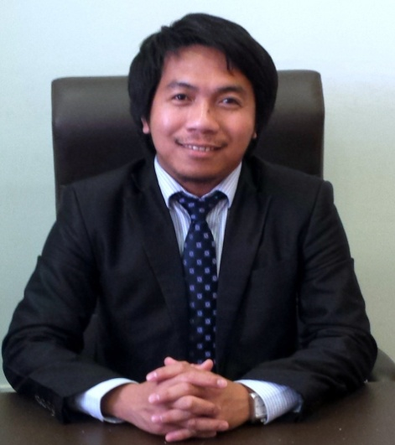

Curriculum Vitae
Mr. Mark
Email: mark.313698@2freemail.com
Mobile phone: Whatsapp +971504753686 / +919979971283

Professional Profile

*Accomplished educator in colleges, academic schools and language center.
* Creative in classroom management and lesson presentation both in written and oral communication.
*Effective and dynamic teacher with the ability to lead, to establish goals and to attain good results.
* Have a strong command over artistic tools to create different arts and provide the medium through which
students can interact

License Teacher

LET passer, Licensure Examination for Teacher, Professional Regulation Commission (PRC),
Bachelor of Elementary Education, Specialization, Science and Health

Teaching Experience

International job

English Teacher, Al Baha University (Project) Al Baha, Saudi Arabia, September 2013 to August 2016
Duties and Responsibilities, Teaching general English in preparatory year to Saudi students.

English Teacher, Al Jazeera International Academy, Riyadh, Saudi Arabia, June 2009 to Present
Duties and Responsibilities, Teaching conversational English and grammar to Saudi, Yemeni, Egyptians, Palestinian,
and other Arab nationalities
English Teacher,(Project) Al Baha University, Al Baha, Saudi Arabia, September 2011 to August 2012
Duties and Responsibilities, Teaching general English in preparatory year to Saudi students.

Local job
Substitute Teacher, Department of Education, Pinamungajan, Cebu September 2008 to March 2009
Duties and Responsibilities, Teaching eight subjects to grade six elementary pupils

English Instructor, University of Cebu (ESL), Banilad, Cebu City, June 2006 to April 2008
Duties and Responsibilites , Teaching grammar and conversational English to adult South Korean students with
different levels

English Instructor, Cebu International Academy, Talamban, Cebu City, November 2005 to May 2006
Duties and Responsibilities, Teaching grammar and conversational English to middle school students from South Korea
with different levels

Special Skills and Abilities
Excellent computer skills in speed tying, PowerPoint, Microsoft Word and Excel,
Guitar Player
Able to interact with all ages
Excellent leadership qualities
Self Motivated
Good organizational skills

Personal Data
Age : 31
Permanent Address: Cebu, Philippines
Civil status : Married

Gender : Male
Religion : Roman Catholic
Weight /Height : 62 kg and 5 ft 4 in.
Dependents
Names Relationship
Grace Wife
Prince Mark Son

I hereby acknowledge that the information stated above is true and correct to the best of my knowledge.
Mr. Mark
Applicant

