**Physics teacher**

**Cell** C/o 0502360357 **Email** [cosman.313752@2freemail.com](mailto:cosman.313752@2freemail.com)

**DOB** 18 September 1982

COSMAN I

PERSONAL PROFILE

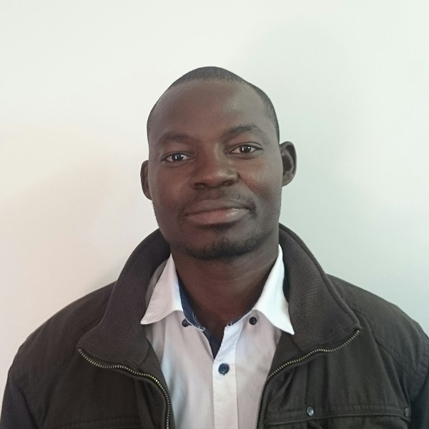

I am an ambitious, enthusiastic and excellent classroom practitioner who has been teaching physics and mathematics for different curriculums for the past 7 years. A game changer who will provide to the school and learners with a learning environment which is caring, motivating and supportive at the same time allowing all cultures within the community to achieve their personal best and to become independent thinker, innovator, problem solver and responsible global citizens. I have 2 years leadership experience in teaching and administration. A technical minded young teacher, good in programing school software such as databases, timetabling and security also certified to use technology in teaching and learning by the use of smart boards and interactive boards. The experience extend to extra curriculum activities as I can coach and coordinate all sort of sports mostly soccer and volleyball. I am a flexible teacher who can teach all science subject, mathematics computers and life skills. Cosman is presently looking for an acceptable teaching position with a suitable school where he will be able to widen his teaching experiences

CAREER HISTORY

**Physics and Mathematics Educator**   
***DEPARTMENT OF EDUCATION MPUMALANGA (DM MOTSAOSELE SECONDARY SCHOOL)*** *January 2011 to present*

* + Teaching Physical science ,Mathematics and computer technology grade 10-12
  + School science curriculum developer
  + Planning and implementing lab-based science lessons based on school standards.
  + Constantly encouraging students to grow learn and improve.
  + Keeping accurate student report cards as well as attendance and discipline records.
  + Using the latest technology in classes (smart board certified).
  + Keeping the science laboratory organized, safe and clean.
  + Reviewing a student’s academic progress against set targets.
  + Dealing quickly with inappropriate student behavior.
  + Modifying lesson plans to heighten learning.
  + Marking a student’s coursework work Involved in shaping the future of the school.
  + Engaging students in active learning and Organising science trips and experiments.
  + Ensuring that all lessons are planned with clear aims and objectives.
  + Working in partnership with other teaching staff on a daily basis.
  + Encouraging all students to be actively engaged in their own learning.

**Physical science and Mathematics Educator**  
***DEPARTMENT OF EDUCATION KZN (MBONWA HIGH SCHOOL)*** *September 2008 – December 2010*

* Curriculum development
* Teaching Physics and Mathematics A Level and O level
* Experiments setup (lab technician)
* Member of Science club (founder)
  + Soccer coach
  + Timetabling and general repairs of school computers

|  |
| --- |
| **Teaching**   * Identifying, selecting and modifying instructional resources to meet the needs of the students. * Carrying out regular assessment of pupil performance, assessing and reporting on subject strengths and areas for development at different stages. * Researching, establishing and implementing programs review and outcome assessment criteria, standards, systems & procedures and integrating the same into future departmental planning.   **Managing Students**   * Assisting & counseling students in grasping contents. * Maintain order and discipline across the school. * Fostering a healthy learning atmosphere in class by recognizing & nurturing the creative potential of each student.   **Educational Leadership**   * Overseeing the development & implementation of objectives and long-range plans for curriculum and instructional evaluation and improvement. * Ensuring the success of all students by facilitating the development, communication, implementation and evaluation of various new educational concepts. * Developing an educational atmosphere where students have the opportunity to fulfill their potential for intellectual, emotional, physical, spiritual and psychological growth.   **Administration**   * Overseeing the daily operations of the school, ensuring compliance with the policies and regulations. * Providing leadership to teaching and administrative staff. * Liaising with Education & other Departments for establishment & smooth running of the institution. * Providing leadership & guidance to the Teaching and Administrative Staff; imbibing discipline in students. * Fostering relationships between the institution and the community; acting as a Resource person for several workshops; orientation programmes, general and subject based. |

KEY COMPETENCIES AND SKILLS

ACADEMIC QUALIFICATIONS

* **University Of South Africa (UNISA) 2016**

POST GRADUATE CERTIFICATE (Physical Science and Mathematics) in progress

* **National University Of science and Technology 2003-2008**Bsc Honors in Applied Physics (2.2)