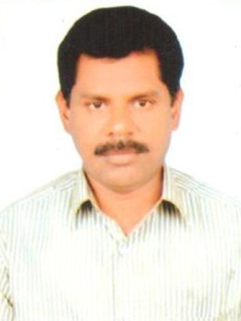
RESUME
ARIVALAGAN
ARIVALAGAN.313832@2freemail.com

CAREER OBJECTIVE:
Seeking a Challenging and rewarding position with a reputed Institution, Where I can explore a dynamic career, acquire new skills and contribute effectively to the institution with my previous work experience.
PERSONAL DETAILS:
Date of Birth : 15-07-1968
Gender : Male
Marital status : Married

Qualification:
Academic : B.Sc., (Applied Sciences)
Govt. College of Technology
Bharathiar University
Coimbatore
Professional : B.Ed.,(Physical Sciences)
Bharathiar University SDE
Coimbatore
PGDELT.,
Post Graduate Diploma in English Language
Teaching, Annamalai University
Undergone Precommission Training in
Indian Air Force, Tambaram, Tamilnadu

Skill sets:
- Developed and implemented daily and unit lesson plans for 10th grade, administered tests and evaluations, and analyzed student performance
- Worked as IXth and Xth grade in charge and successfully guided the teachers and student
- Guided students in science projects – Human impact on Earth, Biodiversity and Wealth from waste
- Fostered a class room environment conducive to learning and promoting excellent Student/teacher interaction
- Working as an Associate NCC Officer in our institution after successful completion of training in Indian Air Force Station, Tambaram in 2010.
Extracurricular activities:
- From school life onwards being football player played in various level tournaments.
- Trekk to Yercaud hills every year with our cadets
Experience:
- At present as a Science teacher and Associate NCC Officer, Air Wing in Sri Vidya Mandir MHSS, Salem Steel Plant, Salem, since July 2008
- From 2003 to 2008 worked as B.T.Assistant in science in Vivekananda Vidyalaya MHSS, Tirupur
Total experience - 16 years
Relevant experience - 16 years
Current CTC - 4 Lacs p.a
Expected CTC - Negotiable
Notice period - Immediate
Location - Sharjah, UAE
Declaration
The above said information is true to the best of my knowledge.

