OBJECTIVE :
Senior Graphic Designer& Fashion DesignerSpecializing in Social Media, Logo Design, Brochures, Visiting Card, UI & UX Design, Poster, Printing Knowledge, Fashion Sketching, Fabric, Many More, Experienced with All Stages of the Designing Cycle &Photography Want to proven ability to make a Strong Impact for a Suitable Visualizer, Fashion Designer, GraphicPosition as The Next Step in Successfully Career.

PERSONAL
INFO :

Name : Parth
Parth.314463@2freemail.com

EDUCATION:

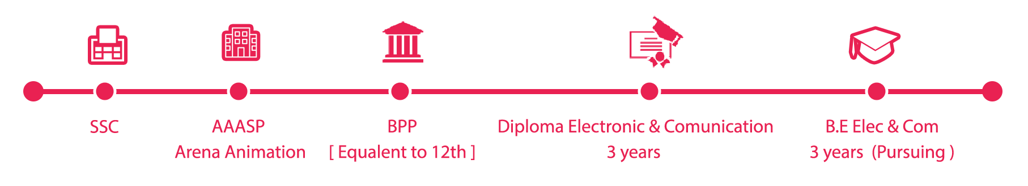

SOFTWARE
SKILL :

ILLUSTRATOR :8 Years Experience PHOTOSHOP :8 Years Experience

CORAL DRAW :8 Years Experience PREMERE :3 Years Experience

HTML5 &CSS :1 YearBasic DREAMWEAVER:1 Year Basic

FLASH :3 Years Experience SOUNDFORGE :8 Years Experience

INDESIGN : 2 Years Experience MS OFFICE :3 Years Experience

PROFESSIONAL SKILL -1 PROFESSIONAL SKILL -2 PERSONAL SKILL

LOGO DESIGN SOCIAL MEDIA CREATIVE
UI/UX DESIGN ILLUSTRATION LEADING
CORPORATE DESIGN PACKAGING DESIGNIG TEAMWORK
WEB DESIGN PHOTOGRAPHY
ADVERTISING TYPOGRAPHY
BRANDING FASHION DESIGN
WORK EXPERIENCE :

- Vice President Channel Head [ Jan 2016 - Oct 2016 ][ Graphic | Print | Editing | Management ] Nashik ENT Channel Vice President Channel .Freedom 365 MMS PVT. LTD.

- Project Handling Sapkal Knowledge Hub School [ Chief Technical Officer - Technical ] [ Jan 2015 - Nov 2015 ] V-Tech Support Pvt. Ltd, Nashik.

- Satyam Designer BoutiqueNashik. [ Fashion Designer ] [Oct 2014 - Nov 2015 ]

- Graphic Designing [ April 2011 - Dec 2016 ] Freelancing [ Aniiwood Advertising]

- Graphic Faculty [ Jan 2009 - Sep 2014 ] Arena Animation [ AptechPvt.Ltd ] – Nashik

- Web Designer [ April 2008 - Nov 2008 ] Zoom Softech Pvt. Ltd - Nashik Road.

PASSION &HOBBIES :
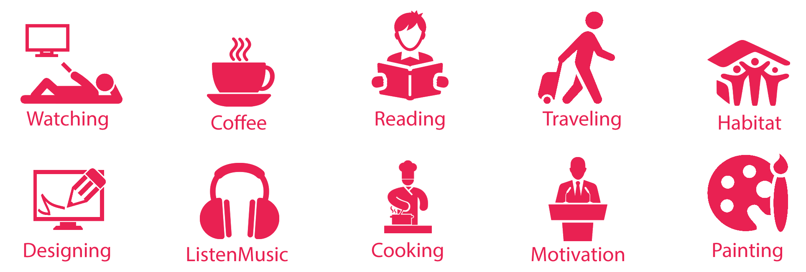

Parth
Dear Sir/Madam,
Re: Application for the Senior Graphics Designer Job Position.
Having elevated the performance and profitability of diverse organizations through expert alignment of innovative Interactive Graphic Design & marketing strategies, I am writing to offer your company 8 years of experience in creative development/leadership of promotional campaigns.
Currently a Freelance Senior Graphic Design professional, I offer a proven ability to conduct creative analysis and design best-fit solutions for multi-faceted campaigns including interactive media, web design, digital photo manipulation and web development. I’ve assisted clients from all backgrounds and industries to design and implement thoughtful and impactful Branding tools to help grow their business.
I have the ability to determine and correct overall website cohesiveness, functionality, and appearance of elements such as navigation tools, page layouts, images, Flash, and form elements in order to increase user experience and drive overall revenues. In addition, I offer innovative and creative design experience. I am now looking for an opportunity to join your team as a Senior Graphic Designer.
Examples of key achievements include:
Enhanced customer satisfaction by creating an easy-to-use, highly intuitive web site based on user specifications. Increased client’s overall business presence, designed various components for rich media websites such as user interfaces, navigation systems, buttons, and video content.
Executed innovative design ideas for magazine or brochure layouts and print media. Optimized company’s marketing collateral with a new modern design, resulting in increased business volume. Strong background in developing and executing branding materials for print, online, and marketing materials. For a more detailed presentation of my skills and background, please review the enclosed resume and feel free to contact me at your earliest convenience. Thank you in advance for your consideration and I look forward to your call.
Sincerely,

