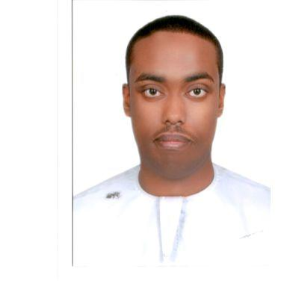
CURRICULUM VITAE

-PERSONAL DATA:
-Name: Abdulqani
-Date & place of birth: 6/02/1996 Ajman -Nationality: Somalia -Marital status: single
-EMAIL: abdulqani.314466@2freemail.com - driving license: yes
-OBJECTIVES :
To pursue a challenging career in a dynamic financial in the area of Administration management & or generational Development, Where the Opportunity to utilize Knowledge and Experience are available for the interest of the company as well as to build up professional career.
-EDUCATIONAL:
- General Secondry Education Certificate.
- Al- Mazaya school for secondary education – sharjah
-Financial Accounting Diploma
TECHNICAL SKILLS:
Computer:
-good in Arabic and English Keyboarding - Good in using Microsoft office (work, Excel, Access, Powerpoint).
Office: - answer the telephone and take messages
-prepare and send mail messages
-prepare letters memos faxes in english and Arabic -filing
-LANGUAGE:
-Arabic: Very Good command in Reading, Writing and Fluent Speaking.
- English: Very Good command in Reading, Writing and Fluent Speaking.
-PERSONNEL & TECHNICAL SKILLS:
-Very good communication skills. -Very good computers (windows & offices)& internet skills. -work discipline. -Hard worker. -Punctuality. - Strong desire to acquire new knowledge.
- Skills at work:
- Computer use and easy to deal with Internet.
- Commitment to official work and scheduled appointments.
- Maintaining secrets and workflow.
Experiences:
I was Work in Customer service for one year in Mcdonalds Sharjah.
- Taking the orders of customer
- Taking the customer's site and register
I was Work in call center for tow year in Ajman Chamber.
- Taking customer inquiries
- Tell him steps registration certificate of origin
- transfer the call
-Greetings: - I thank you for taking the time to have a look at my profile. - I really hope we can secure and land a suitable job within your Esteemed Organization. -Again I appreciate all the efforts and really hoping we can have a sit down and discussed job opportunities.

-Available Immediately -Kind Regards -Abdulqani

