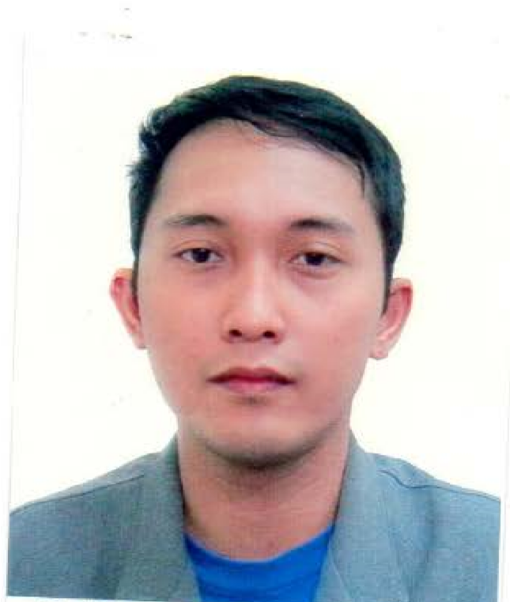PROFILE:

NAME: Lloyd

Lloyd.314546@2freemail.com

CAREER OBJECTIVE:

A registered nurse with ample experience providing quality care to a wide variety of patients.
As an experienced nurse I would like to join a medical center that offers me a constructive and challenging work environment for enhancing my nursing skills and contribute in reaching optimal healthcare standards.
Aiming to employ my deep passion and capability in providing safe, effective, and efficient nursing care.

LICENSES:

Basic Life Support (BLS) Certification – CPR and AED Program
Health Force Training Center (

2016 – 2018

Professional Regulation Commission
Registration No.:
Oct. 2009 – May 2019

Certificate of Employment – Golingay General Hospital 2009 – 2011
SKILL HIGHLIGHTS:
- Health and wellness expertise • Enthusiastic caregiver
- Medication administration expert • Diabetes, Hospice and Stroke Patient Care
- Skilled in conducting physical • Familiarity with disease management examinations programs
- Geriatric treatment knowledge • Wound cleaning/care expertise
- Broad medical terminology knowledge • Infection control standards expert
- Effective policy and program development • Acute and rehabilitative care
- Culturally sensitive • IV drug therapy management
PROFESSIONAL EXPERIENCES:

- STAFF NURSE

Worked as a staff nurse in infirmary hospital and specialized in areas like:

1.Emergency Room
- Utilized the nursing processes; assessed, planned, provided and evaluated nursing care
- Established nursing diagnoses and wrote out plan for treatment. Implemented cure and evaluated care.
- Demonstrated awareness of ongoing ER unit needs to provide other team members with leadership and direction for reaching optimal nursing care standards.
- Collaborated with other ER professionals to ensure effective patient care delivery – Identified patients’ conditions and addressed nursing care.
- Assisted in the efficient operation of Emergency Room unit – Performed various medical assignments as required.

2.Delivery Room
- Establishes rapport with patients
- Completes and organizes data on worksheets
- Perform and perineal asepsis and antisepsis on patients who are about to deliver
- Maintains and responsible for the cleanliness, orderliness, sterility in the area and constant availability of sterile instruments, linens, supplies and medicines and proper functioning of equipment's being used
- Prepares, administers and documents accurately medications, treatments and supplies rendered to the patient
- Assist the obstetrician during the delivery
- Assist the pediatrician for newborn care
- Notifies OR personnel the procedures to be performed in the OR and facilitates the information to responsible parties regarding the patient’s status and signing of consents for certain procedures to be performed after being appraised by the AP.
- Gives health teachings to patients and family.

3.Medical-Surgical Ward
- Administered prescribed medications, started intravenous fluids, and documented patients' charts by recording food and fluid intake and output
- Answered patients' calls and determined how to assist them, as well provided family support
- Measured and recorded patients' vital signs, such as height, weight, temperature, blood pressure, pulse and respiration

- Provided basic patient care and treatments, such as dressed wounds, treated bedsores, gave enemas, douches, and performed catheterizations
- Assisted patients with bathing, dressing, maintaining personal hygiene, moving in bed, standing and walking
- Integral member of a health care team charged with assessing patient needs, planning or modifying care and implementing interventions

•Private Duty Nurse

Worked as a PDN for 3-months and cared for patients with diabetes mellitus and stroke.

- Participated in various community health programs like:
  - Health teachings
  - Vaccinations
  - Blood pressure screening

- Performed various medical procedures such as:
  - Foley catheter insertion and removal
  - Nasogatric insertion
  - Blood transfusion

HIGHEST EDUCATION:

Education Level: Bachelor's / College Degree
Education Field: Nursing
Course: BACHELOR OF SCIENCE IN NURSING
School/University: Davao Doctor College
Date: 2004 – 2008

PERSONAL DETAILS:
Age: 28 years old
Birthdate: 14 May 1988
Citizenship: Filipino

