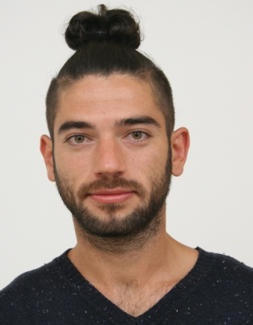 Antonio
Antonio.315028@2freemail.com
DoB: 25.01.1990 PoB: Bitola, Rep. Of Macedonia

CHIEF VIDEO PROJECTIONIST / TECHNICIAN

§  § | Highly Effective Organised  Excellent Interpersonal Skills | §  § | Trouble Shooting and Problem Solving  Remain Calm in Stressful Situations
§ | Accurate, Fast and Efficient | § | Excellent Attention to Details
§ | Excellent Communication Skills | § | Remarkably Talented and Skillful
§ | Enthusiastic Team Player with a Consistent Positive CAN DO | §  § | Friendly, Helpful and Patient  Self-motivated
 | ATTITUDE | § | Professional and Courteous
§ | Strong Aptitude for Multitasking

COMPUTER SKILLS

§ Both, Windows and Mac OS
§ Microsoft Word
§ Excel
§ Outlook
§ Power Point
§ Basic Adobe Photoshop

DEMONSTRATED ABILITIES

VIDEO PROJECTIONIST / TECHNICIAN

§ Great ability to control and operate equipment and systems.
§ Excellent hearing, eyesight and manual dexterity.
§ Ability to perform routine maintenance on equipment and determine when and what kind of maintenance is needed.
§ In-depth ability to make the right choice about the kind of tools and equipment needed for the job.
§ Determination of fixing errors.
§ Communication and dissemination techniques and methods.
§ Profound knowledge of theory and techniques required to perform works of visual arts.
§ Solid understanding of information technology, computer hardware and software.
§ Excellent written and spoken communication skills, ability to read, understand and follow directives and procedures.
§ Experienced with training and supervising new hires.
§ Highly familiar with theatre operations.
§ Extensive experience for using multiple projectors.

BARTENDER

§ Superior customer service, providing true hospitality and guest services.
§ Meet and greet clients / customers in a professional and courteous manner.
§ Extremely strong communicational and organizational skills.
§ Managerial and supervisory experience.
§ Strong marketing skills.
§ Very entertaining behind the bar on busy nights.
§ Friendly and enthusiastic, with sense of humor.
§ Bar maintaining and supplies ordering.
§ Ability to work under pressure.

PROFESSIONAL EXPERIENCE

§  § | CHIEF Video Projectionist /  Technician  Video Assist Operator | National Theatre of Bitola, Republic of Macedonia  Various Projects / Filmmaking Industry | Mar.2009-Sep.2016
§ | Bartender | Lounge Bar”Jagoda”, Bitola,R.Macedonia | Nov.2015-Jun.2016
§ | Bartender | Cabaret / Nightclub ”Lektira”, Bitola, R.Macedonia | Jan.2011-Sep.2015

ACCOMPLISHMENTS

After seven and a half years in the theatre, I have well learned to step up in the hot plate when a challenging situation comes up and to never shy away from it! I always give my best shot and in situations where I believe are over my head, I do ask for help! My biggest professional accomplishment goes back at the time when after three years of hard-working, I got a promotion and became CHIEF VIDEO PROJECTIONIST / TECHNICIAN in the National Theatre of Bitola!
Simultaneously, I took ownership and offered all my strengths, availability and knowledge, helped the department by developing and training the staff, offered high service standards to our clients and guests while performing my duties as a BARTENDER in nightclubs and lounge bars. As a bartender, having a history of exceeding guest expectations by providing them an exemplary service, according to the brand standards of service and style!

ACADEMIC QUALIFICATIONS

§ | I.T. COLLEGE DIPLOMA | St.Clement of Ohrid University – Bitola, Rep. Of Macedonia | Sep.2008 – May.2016
§ | HIGHSCHOOL GRADUATION |  | 2008

OTHER QUALIFICATIONS

§ | DRIVER LICENCE | Licence Class : B | 2008

