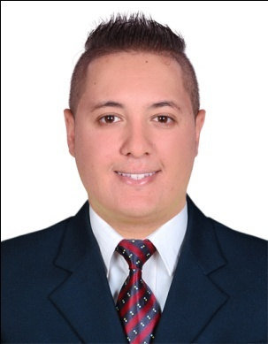
CURRICULUM VITAE

OUSSAMA
OUSSAMA.315266@2freemail.com

CAREER OBJECTIVE
An opportunity to apply and develop my skills in position where I can use my skills and experience I have the working attitude and excellent interpersonal skills that generate great impact and foster harmonious relationship within the company.
ACADEMIC EDUCATION AND QUALIFICATIONS
- Higher secondary school
- Certificate of master swimmer
WORK EXPERIENCE
- Working as a receptionist front desk in IBN NAFEES MEDICAL CENTER ABU DHABI UAE from 2013 till now.
- Working as archives clerk in CITY HOSPITAL morocco from 2012 till 2013
- Working as a life guard with civil protection in morocco from 2009 till 2011
PROFESSIONAL TRAINING
- Customer care training .
- Front office cross training
Office skills
- Handle the pressure of work.
- Hard working and punctual.
- Ability to learn quickly .
- Customer service & customer care .
- Receptionist skills .
- Cash handing .
- Answering the telephone and talking massages .
- Assist VIP guests and escorted them to correct destinations
Computer skills
- Internet qualification.
- Program works.
- Typing English.
- Ms Windows.
- Ms Word.
LANGUAGE
- Arabic ( read, write, speak )
- English ( read, write, speak )
- French ( basic )
- Spanish ( read, write, speak )

PERSONAL SKILLS

Cooking food and barbecue with my friends.

Sport:swimming, wakeboard, bodybuilding, paddaleboarding and football.

Description
I hereby confirm and assure that the above details are true and correct according to my knowledge and should you required character person references , shall be available upon your request .

