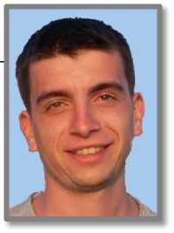
Branko

Branko.315490@2freemail.com

WORK EXPERIENCE
Position and task: | Private school“Gross” Nis  Manager -teacher-Lectures, organization of classes and curriculum. | 2010-
Position and task: | Private school“NIJANSA” Prokuplje  Teacher- Lecture IT skills young children. | 2007  2010.
Position and task: | Cultural Center"Radivoj Uvalic Bata" Prokuplje  Teacher- Lecture IT know small groups of students. | 2005  2007.
Position and task: | Private practice in the cities of Nis Prokuplje Beograd  Teacher-Classes just for one student. | 2002  2005.

EDUCATION
College-Bachelor of Electrical Enginering and Computer Science High school - Gymnasium , natural mathematics oriented
LANGUAGES
English (write - excellent, reading- excellent, speech-excellent) Norwegian (A1 level)
COMPUTERWORK
HTML5 / CSS3 / jQuery / Boostrap / AngularJS /Google sketchup Responsive desing / Photoshop / Wordpress /Microsoft Office...
PERSONAL ATTRIBUTES
Communicative, responsible, determined, energetic, dynamic
OTHER
Driving license B • B1 • BE • C1 categories

