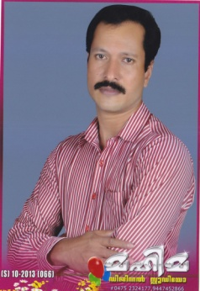
CURRICULM VITAE
Saji

Saji.315528@2freemail.com

Career Objective
To secure a challenging position in an esteemed organization by becoming the part of the team that dynamically works toward the growth of the organization.
Academic Records
Plus Two
I.T.I (BASIC ELECTIRICAL ENGINEERING)
POST I.T.I MOTOR REWINDING COURSE
Professional Experience
- Presently working as a Sr Electrician in Emrill Facilities Management Dubai from June-2014 to till date.
- Worked as Electrical foreman in Qatar 2010-2012.
- Worked as Electrician in Dubai 1997-2002.
- Worked as Electrician in India 1994-1997.
LANGUAGES KNOWN
English, Hindi, Kannada, Malayalam and Tamil
Personal Profile
Date of Birth : 25.05.1972
Marital Status : Married
Nationality : Indian
Religion : Christian

Personal Summary:
- Efficient and well behaved person
- Very energetic result oriented and organized
- Ability to work well in terms
- Fast adaptive leaner with excellent power to learn
Details of experience:
I have the experience in electrical field both construction and maintenance. Fifteen years experience in electrical field and still working in a facilities management company in Dubai freezon.
Experience in construction define as conduiting in PVC and GI, including mould, screed,and wall, box fixing, DB fixing, SMDB fixing, wiring, earthing and megering, continuity testing, DB dressing, device fixing, Light fittings, transformers and outstructures cable laying, glanding and terminations, earthling, panel erections. Tray and trunking works, etc. and to co-ordinate the workers as per the site condition depending-up-on drawing, whatever the workers facing the problems sort out with the higher authority and get work fast and keep the timings and raise the RFI.
Experience in maintenance is define, maintenance of DB, SMDB and MDB and maintenance of lighting control panel and emergency control panel, filtration pump, dozing pump, circulation pump, sump pump and its panels control wirings, device fixing, maintenance of motors control centre, maintenance of parking lights, garden lights, under water lights, and PPM work of all panels in daily, weekely and monthly observe the all panels determine and find out the problems immediately and arrange the materials and arrange the workers as per the site condition.
Declaration:
I hereby declare that all the details furnished above are true to the best of my knowledge and belief.

