CURRICULUM VITAE
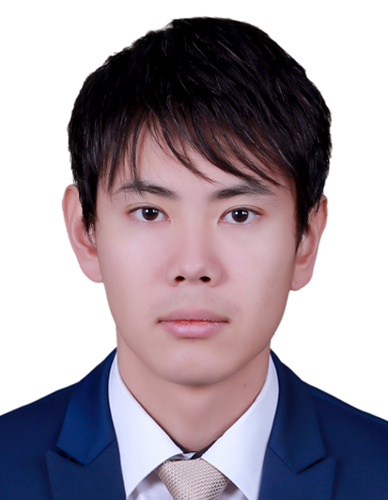
PERSONAL INFORMATION
Name : Yuki
Yuki.316140@2freemail.com
Date of Birth : 26/07/1988
Marital Status : Single
Nationality : Japan

EDUCATION
- 2014-2017
Master Degree in Manouba University, معهد الصحافة و علوم الأخبار, L’Institut de la Presse et des Sciences de l’Information, Specialty of Journalism Writing and Electronic, in Tunisia
- 2011-2013
Meiji University Graduate School of Political Science and Economics, Master’s Degree Program of Political Science, in Japan
- 2007-2011
Meiji University, Department of History and Geography, Specialty of Geography, in Japan

PROFESSIONAL EXPERIENCE:
- 2016 September – 2017 March, Global Customer Support Executive - Kuoni, GTA Travel, Dubai Office
GTA Travel is a Wholesales Company of B to B business in the tourism sector. The main functions of this company are to purchase hotel rooms, transfer service, sight-seeing, tour guide and so on from suppliers and sell those services for travel agents in the world.
My role in this company was to solve difficulties of travelers like hotel quality complain, no reservation issue, direct charge by mistake, miss meet with driver and so on. In particularly, I had handled on the road issues. When the business partners like hotel, supplier, travel agent and traveler contact us by telephone and E-mail to complain their problems, we must immediately provide their requirements.
Once we got an issue, we record it on Sales Force in order to share it with our Team.

DUTIES
- Solving on the road issues
- Confirming hotel booking
- Handling telephone from supplier, agent and guest
- Replying to E-mail
- Relocating guest who cannot be accommodated by original hotel
- Raising each issue on Sales Force and sharing it with colleagues
- Negotiating with hotel to be refunded for problems of booking, quality complain and direct charge from guest by mistake
- Refund procedure to the agent
- Contacting supplier in miss meet case
- Requesting to hotel for guest’s need

QUALIFICATIONS
- 2014
Certificate of French Language, DELF B2
- 2013
High School Teacher’s Superior Certificate of Civics, in Japan
- 2012
High School Teacher’s Certificate of History and Geography, in Japan

