PRATJITHA
Pratjitha.316246@2freemail.com 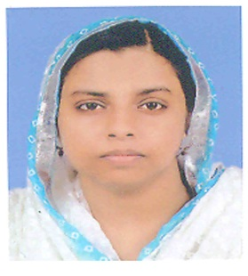

OBJECTIVE
To be a part of reputed organization which provides opportunity for me to enlarge my knowledge skills and thereby contributing to the success of organization and leading to my career growth.

EXPERIENCE
Company: Sevana Medicines, Edappal
Position: Pharmacist
Duration: 19/05/2013 to 20/08/2015

Role
- Order and purchase pharmaceutical supplies, medical supplies, and drugs, maintaining stock and storing and handling it properly.
- Assess the identity, strength and purity of medications.
- Advice customers on the selection of medication brands, medical equipment and healthcare supplies.
- Maintaining records regarding stock and pharmacy movements.

Company: Nursing Home, Tirur
Position: Pharmacist
Duration: 01/01/2009 to 30/06/2011
Role
- Dealing with customers on their requirements.
- Checking the medicine quality and quantity.
- Arranging stock items.
- Producing daily and monthly report.
- Good hand over the counter sale (OTC).

Company: Life Care Medicals, Thrikkanapuram.
Position: Pharmacist.
Duration: 01/01/2013 to 30/04/2013

Role
- Order and purchase pharmaceutical supplies, medical supplies, maintaining stock and storing and handling it properly.
- Advice customers on the selection of medication brands, medical equipment and healthcare supplies.
- Maintaining records regarding stock and pharmacy movements.

Educational Qualification
- Passed out SSLC (Secondary School Leaving Certificate) from Fathima Matha English Medium
School, Tirur.
- Passed out HSSC (Higher Secondary School Certificate) from MSMHSS, Kallingalparamba.
- Graduated as D-Pharm holder from T.D Medical College- Vandanam, Alappuzha.

Computer Proficiency
- Diploma in Computer Application.
- MS Office Applications (MS WORD, MS EXCEL, MS POWERPOINT).

Languages Known
English, Malayalam, Hindi and Arabic.

License Details
MOH Kerala State Pharmacy

Personal Profile
Age : 32 (21/04/1984).
Gender : Female.
Marital Status : Married.
Religion : Islam.
Nationality : Indian.

Declaration
I hereby declare that, the above detailed information is correct and true to the best of my knowledge and beliefs.

