Sameh

Curriculum Vitae
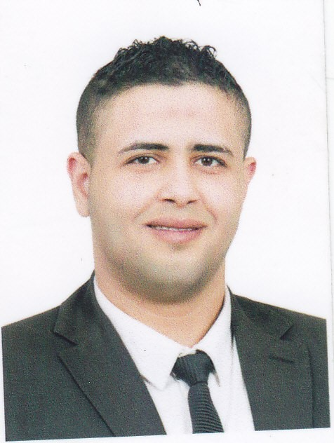
Sameh

UAE C/o 0505891826
E-mail: sameh.316466@2freemail.com

Name:
Date of Birth: 15 may1990
Nationality: Egyptian
Marital Status: Single
Visa: Resident visa

Language Skills:

- Arabic Language:(Mother Language) Excellent in Speaking, Writing, Reading and
Listening skills.
- English Language: Excellent in Speaking, Writing, Reading and listening skills.

Pursue a challenging and rewarding career in an organization which can provide me competitive and professional environment, whereby my skills along with academic background and experience will be utilized to mutual benefits.

Job title: | Sales & Marketing
Company Name: | Fly DUBAI
Job Description: | I work in Fly Dubai company as customer service agent that is important job in my career , Because the roof is not my ambition has always wish How then bigger and bigger chance to prove myself as I hope to work in an environment that allows me creativity and implementation of ideas outside the box
Duties :  2015 | - Regardless of the communication channel, efficiently service customers providing accurate and timely responses, understand, interpret and resolve issues quickly and decisively.  - Confers with customers by telephone in order to provide information about product and service.  - Keep records of customer interactions and transactions, recording details of inquiries, complaints, and comments, as well as actions taken.  - Attract potential customers by answering product and service questions suggesting information about other products and services.  - Resolves product or service problems by clarifying the customer's complaint determining the cause of the problem selecting and explaining the best solution to solve the problem.  - Record details of customer contacts and actions taken  - Maintaining a professional image at all times.  - Working closely with small and medium sized businesses.  - Putting into effect new procedures and policies passed down from Head Office.  - Marketing new financial products or services.  - Presenting information clearly to customers, work colleagues and third parties.

Job title: | Sales Executive
Company Name: | National bank of Egypt
2013 - 2014
Job Description: | I worked at Citi bank of Egypt for a year and three months. Provided everything I can to achieve the best numbers. My own Strategic sales depend on three types of customers which targeting three types according to the needs of each of them.  Understands the needs of the different layers expanding marketing department, sometimes client can resolved the required monthly figure targeted in minutes and there is a kind of small clients can their presence in abundance  In all cases, my own strategy aimed at three types of clients to achieve the best numbers
Duties : | - organising sales visits  - demonstrating/presenting products  - establishing new business  - maintaining accurate records  - attending trade exhibitions, conferences and meetings  - reviewing sales performance  - negotiating contracts  Promotional prospects are excellent - progression can be into senior sales roles or into related employment areas such as marketing or management.
PROFESSIONAL QUALIFICATIONS (TRAINING):

- HR diploma " nlp , development and changing , the power of positive thinking "
- Professional diploma program in " marketing , sales management

Graduated from High Instituta of Social Servicie

Personal
- Customer service
- Product knowledge
- Quality Focus
- Problem Solving
- Market Knowledge
- Documentation Skills
- Listening , Phone Skills
- Resolving Conflict
- Analysing Information

