AJEESH

AJEESH.316643@2freemail.com
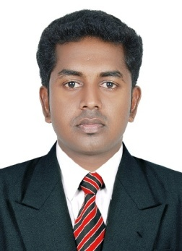

Objectives
To elaborate and fabricate myself with cutting-edge skills, to fulfill highest quality in all stages of business development, and be an eminent professional as well as an efficient team member, always focus on company growth for achieving excellence by delivering highest quality of work.

Education

Year of Passing | Qualification | Board/ University | Percentage of mark
2011 | BBA | M.G University | 67%
2008 | Plus two  (commerce) | Kerala State Board | 66%
2006 | SSLC | Kerala State Board | 66%

Experience
One and half year Work experience as an Accountant in prabha jewels industries (India) pvt ltd, Malappuram.
One and half year Experience as an HC insurance Sr. representative in Dell company (BPS) at IT SEZ COimbatore.
Technical Skills
- Experienced with Microsoft Word, Excel, Outlook, Power Point.
- Tally, Peachtree, Quick books (DIFA)

Soft Skills
- Team work
- Coordination

Project detail
- Social project (problems faced by passengers in railway)
- Management project (new performance appraisal programme in Big Bazar Palakkad)
Other interests
- Travelling.

Languages known
English ,Malayalam and Hindi

Personal details
Date of birth :11.08.1990
Gender :Male
Nationality :Indian
Marital status :Single

Visa Status : Visit Visa
Visa validity : till 15th Nov

Declaration
I hereby declare that the above-mentioned information is correct up to my knowledge and I bear the responsibility for the correctness of the above-mentioned particulars.

