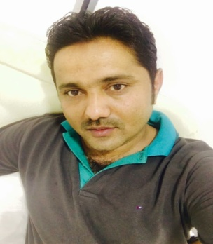
Muhammad
Muhammad.316662@2freemail.com
Objective:
- Seeking a position consist with my skills and background that utilizes my proficiency as REGISTERED NURSE.
- 12 years of experience as STAFF NURSE and HEAD NURSE.
- I pride myself on being able to work both in a team and on my own initiative.
- Hard working goal oriented dependable and reliable in supporting and enabling team effort to produce more services.

PROFESSIONAL LICENSE:
- Dubai Health Authority License ( Registration Number :
- Pakistan Nursing Council National institute of Health Sciences, Islamabad Pakistan (Registration Number :
- HAAD license ( Registration Number:
- BLS Passed

PROFESSIONAL EXPIERNCE

Registered Nurse
Health and Life Medical Centre , Abu Dhabi

Feb, 2015 to Date

Registered Nurse
Al Arif General Clinic
Al Arif Group of Companies, Dubai, Uae.
April, 2009 to December, 2014
- In collaboration with other health team member utilizing the nursing process to plan, implement and maintain the plan of care of individual patient
- Managing injuries like fractures, sharp & blunt traumas, strains, sprains & heat strokes of site workers
- Escorting seriously ill patients to hospital for advanced medical treatment
- Coordinate with other departments regarding training schedules, delegates profile & special consideration
- In charge of documents for filling before & after each training
- Asses client needs & provide optimum solutions to health & safety concern
- Conducts facilitates and demonstrates “First Aid training courses according to latest standards international guidelines to all level of employees
- Patients support through assessment counseling & education regarding medication & treatment

Registered Nurse
Liaquat National Hospital, Karachi
Feb, 2002 to October, 2008
- Worked as Head Nurse in Medical & Surgical wards
- Managing a team of 20 RN’s & 05 Nursing assistants
- Dealing with seriously or terminally ill clients
- In collaboration with other health team members utilizing the nursing process to plan, implement & maintain the plan of care for individual patient
- Closely monitor ECG changes, laboratory results insert folys catheter, Intravenous Cannulation & Vital sign
- Manipulate medical machines & equipments Cardiac monitors, pulse oxymeter and enteral feeding
- Initiates plan of care, pre & post surgery and identify nursing & medical needs of patients by giving direct & comprehensive nursing & medical care to prevent complication

PROFESSIONAL QUALIFICATION:
- General Nursing Bachelors from Liaquat National Hospital, Karachi in 2002

ACADMIC QUALIFICATION:
- Intermediate from BISE Hyderabad
- Matriculation from BISE Hyderabad

